

Getting Ready for Fine Motor Activities

Why Warm-Up Activities Help
Children can find it helpful to warm up their muscles before activities that need hand control, like writing, drawing, colouring or cutting.
A short warm-up routine can help improve concentration, posture, hand strength and finger control. These activities can be done at home or in school. They should take no more than 5 to 10 minutes.
Start with activities that use the larger shoulder and arm muscles. Then move to the smaller muscles in the hands and fingers.

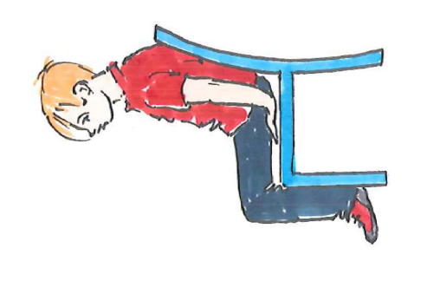
Shoulder and Arm Warm-Ups

Chair Push-Ups
Sit upright in a chair and place hands on the sides or seat of the chair.
Push down through your hands to lift your bottom slightly off the chair.

Desk Push-Ups
Place both hands on a desk. Make a triangle shape with your
thumbs and index fingers. Bend your elbows to bring your nose
towards the triangle. Then push back up.

Shoulder Shrugs
Lift your shoulders up towards your ears, then relax them down. Repeat several times. Next, roll your shoulders forwards and backwards.

Crocodile Snaps
Stretch your arms out in front of you. Placing one arm above the other. Snap your hands together like a crocodile's jaws. Swap which arm is on top.

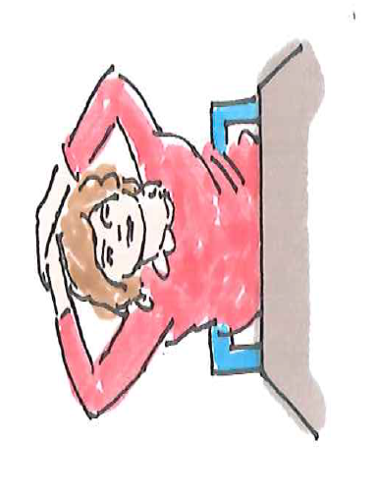
Head Press
Place both hands on top of your head and gently press down
while keeping your head upright.

Air Traffic Controller
Start with bent elbows and fists near your shoulders.
Stretch one arm out to the side while the other moves forwards. Change sides.

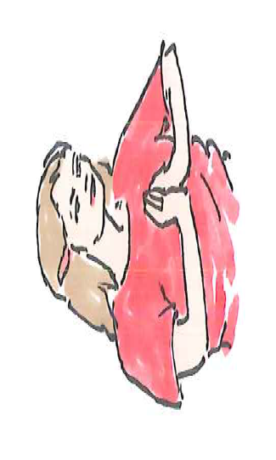
Butterflies
Link your thumbs together and stretch your arms out in front. Make
small circles using your shoulders, like fluttering butterfly wings.

Hand Push and Pull
- Push: Press your palms together firmly for 5-10 seconds.
- Pull: Hook your fingers together and gently pull against
them for 5-10 seconds.

Hand and Finger Warm-Ups

Star Hands
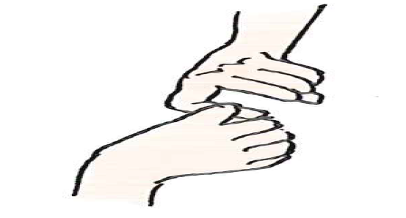
Stretch your fingers out as wide as possible to make a star shape, then squeeze them into a tight fist. Repeat several times.

Piano Fingers
Tap each finger on a table one at a time, like playing the piano. Try playing slowly, then quickly.

Finger Pulls
Link the same finger from each hand together and
gently pull. Repeat with each finger.

Pencil Twirls
Twirl a pencil between your fingers or spin it gently like a baton.

Penny Twirl
Move a coin or small object around your fingers using one hand only.

Inchworm Pencil Walk
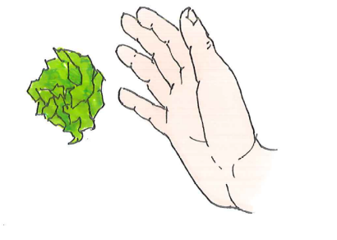
Using your writing hand, "walk" your fingers up and down a pencil without using your other hand for support.

Paper Scrunching
Using one hand only, scrunch a piece of paper into a tight ball.
Try each hand separately.

Top Tips
- Keep activities fun and playful.
- Little and often works best.
- Aim for 5-10 minutes before writing or other fine motor tasks.
- Encourage effort rather than perfect performance.
- Join in with your child to make the activities more enjoyable.

Remember
Strong shoulders, arms, hands and fingers are important for good handwriting and other everyday skills. Regular practice can help children feel more confident and successful when completing fine motor activities.

Children's Occupational Therapy Service
Supporting children and families to develop skills for everyday life.

