

Helping Your Child to Focus when Taking Part in Activities
Some children find it difficult to stay focused during activities at home or school. They may appear constantly on the go, fidget frequently, talk a lot, seem easily distracted or appear tired and unmotivated.
Difficulties with attention can be linked to:
- Tasks being too easy or too difficult
- Difficulties understanding instructions
- Sensory processing differences
- Tiredness, anxiety or stress
Remember, all children have different ways to help themselves focus. Some need movement. Some prefer to have background noise. Some can concentrate best when their hands are busy.

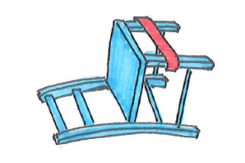

Classroom and Homework Strategies
Strategy | How it Can Help
Good seating position | Improves posture and concentration
Clear workspace | Reduces distractions
Standing to work | Can help some children focus better
Fine motor activity box | Gives them something to focus on when changing tasks
Fidget tools | May help some children stay focused
Wobble cushion | Can provide movement while remaining seated
Stretchy bands on chairs | Gives children a way to move their legs quietly
Regular movement breaks | Helps children stay well regulated and focused

Creating a Supportive Environment
Think about | Suggestions
Visual distractions | Reduce clutter and unnecessary displays
Noise levels | Use quieter spaces when possible
Lighting | Make sure work areas are well lit
Temperature | Make sure the environment is comfortable
Positioning | Sit near the teacher or away from distractions if needed
Workload | Break tasks into smaller, achievable sections
Timing | If your child can focus for 2 minutes, start there and slowly increase expectations over time
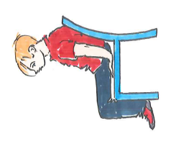

Movement Breaks

Regular movement can help children stay alert and focused.
Activity | Examples
Quick Movement Breaks | Marching on the spot, star jumps, jumping, arm circles, stretching, chair push-ups, wall push-ups
Position Changes | Standing, kneeling, lying on tummy, propping on elbows
Helpful Jobs | Delivering messages, tidying equipment, moving chairs or carrying books
Warm-Up Activities | Hand and arm warm-ups before writing or table-top tasks

Alerting Activities
Some children need extra sensory input to help them feel awake and ready to learn.

Activity Type | Examples
Strong Flavours | Citrus fruits, strong mints, sour flavours (as appropriate)
Cold Foods | Frozen fruit, smoothies, ice cubes with fruit
Vibration | Electric toothbrushes or vibrating sensory tools
Movement | Jumping, running, dancing, skipping

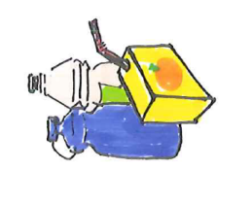
Oral and Sensory Strategies
Activities involving chewing, sucking, blowing and drinking can help some children stay calm and focused.
Activity | Examples
Drinking | Water bottles with sports tops, drinking thick liquid through wide straws
Chewing | Chewy snacks, chewable jewellery (where appropriate)
Oral Sensory Tools | Chew pendants or oral sensory toys under supervision
Blowing Activities | Bubbles, pinwheels, balloons, party blowers
Mouth Motor Games | Blow football, blowing tissue races, blowing bubbles in water

Remember
Every child is different. What helps one child focus may not work for another. Observe what helps your child stay calm, alert and engaged and use these strategies regularly throughout the day. Small changes to routines, or the environment, can make a big difference to your child's ability to take part and learn. 😊
Children's Occupational Therapy Service
Supporting children and families to develop skills for everyday life.

