

Organising Myself for Activities

Why Might My Child Find Organisation Difficult?
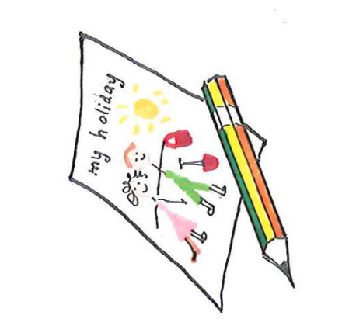
Some children find it harder to organise themselves, follow routines, manage their belongings or complete tasks independently. This may be linked to difficulties with attention, understanding instructions, body awareness, sensory processing or planning and organising their actions. Simple things can make a big difference both at home and at school.
Tips for Primary School Children

Break Tasks into Smaller Steps
- Split routines into simple, manageable steps.
- Give 1 instruction at a time where possible.
- Encourage your child to repeat instructions back to you.

Use Visual Supports
- Create picture or written checklists for daily routines and tasks, such as packing bags or getting ready for school.
- Use colour coding to help identify where to start and finish writing on the page.

Reduce Distractions
- Provide a tidy workspace. Keep unnecessary clutter to a minimum.
- Position your child where they can easily see and hear instructions.

Help Your Child Stay Organised
- Use labelled trays, drawers or containers.
- Keep items that are used often in the same place.
- Use desk organisers, pencil cases or picture labels.

Gain Your Child's Attention First
- Make sure your child is looking and listening before giving instructions.
- Use clear, simple language.
- Praise good attention and listening.

Tips for Secondary School Children

Use Organisational Tools
- Keep a homework diary or planner.
- Colour-code subjects, books and folders.
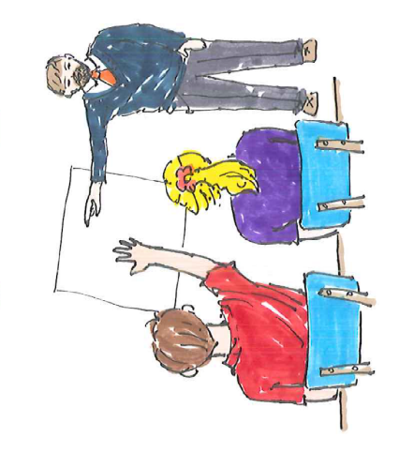
- Use reminders on watches, phones, calendars or apps where appropriate.

Prepare in Advance
- Pack school bags the evening before.
- Use checklists to remember equipment and homework.
- Keep a copy of timetables in several places.

Keep Work Organised
- Use folders with separate sections for each subject.
- File worksheets regularly.
- Highlight important information in notes and homework tasks.

Reduce Stress
- Encourage your child to break larger tasks into smaller steps.
- Use calendars to plan homework and revision.
- Build routines around schoolwork and daily activities.

General Strategies
- Involve your child in choosing organisational strategies that work for them.
- Be consistent at home and school where possible.
- Use visual reminders, checklists and routines regularly.
- Praise effort and independence.
- Gradually reduce support as your child's confidence grows.

Remember
Organisation is a skill that develops over time. With practice, routines and the right support, children can become more confident and independent in managing their activities, belongings and schoolwork.
Children's Occupational Therapy Service
Supporting children and families to develop skills for everyday life.

