

Messy Play

Why is Messy Play Important?
Messy play is a fun way for children to learn and develop important skills. It encourages children to explore different textures and use their imagination. It also helps to develop hand skills needed for everyday activities such as writing, dressing and using cutlery.
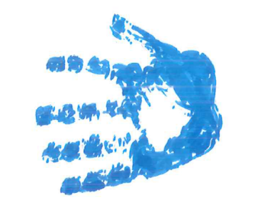
Messy play can help to develop:
- Hand strength and fine motor skills
- Hand-eye coordination
- Creativity and imagination
- Social and communication skills
- Concentration and problem-solving
- Confidence exploring new experiences
Some children may be sensitive to certain textures and may avoid messy play. This is common and can be improved by introducing new textures gradually and at your child's own pace.

Preparing for Messy Play
Before messy play, some children benefit from activities that provide deep pressure and help them feel more comfortable using their hands. Try:
- Animal and wheelbarrow walks
- Gentle hand massages using hand cream
- Hand hugs. Do this by gently pressing around the hands and arms.
- Playing with water if your child enjoys it

A Gradual Approach to Messy Play
If your child is reluctant to touch messy materials, start with dry, firm textures and slowly introduce softer and wetter materials. The aim is not to get messy quickly, but to help your child gradually feel comfortable exploring a range of different textures. 😊🖐️

Messy Play: A Gradual Approach to Exploring Textures
Stage | Activities | Ideas to Make it Fun
Step 1: Dry Materials | • Lego or Duplo  • Large dried pasta  • Beans or lentils  • Rice | • Make patterns and pictures  • Draw shapes with fingers  • Practise pouring and scooping
Step 2: Mixed Textures | • Smaller pasta shapes  • Sand or flour mixed with dry materials | • Hide objects to dig out  • Pour, scoop and fill containers  • Explore different textures together
Step 3: Add Water | • Damp sand or cornflour  • Mud kitchen play  • Coloured water | • Add water a little at a time  • Make potions or mud pies  • Mix, stir, pour and scoop water and food colouring
Step 4: Softer Textures | • Playdough  • Cake mixture  • Dough and pastry  • Slime or gloop  • Jelly | • Squash, squeeze, spread and roll  • Hide objects inside  • Use cutters, spoons and moulds

Messy Play and Feeding
Some children who are sensitive to textures may also find certain foods difficult to touch or eat. Allowing children to explore food through play can help build confidence.
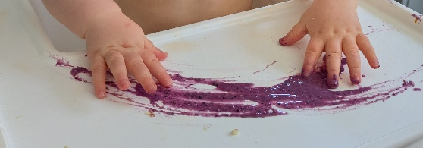
Start with drier textures. This can be things like cereal, oats and crushed biscuits. Then move gradually towards wetter foods like rice pudding, yoghurt, jelly, custard and smooth jam. Allow your child to touch, squeeze, stir, pour and explore foods without pressure to eat them. Encourage them to join in with cooking and baking activities such as stirring ingredients, mixing cake batter, kneading dough and rolling pastry.
Taste Safe Messy Play:
- Smoothies
- Frozen berries
- Yoghurt. Plain or flavoured yoghurts add colour.
- Rainbow spaghetti. Drain cooked pasta and add food colouring.
- Edible ‘mud’. Use whisked chocolate pudding or mix 1 cup flour or cornflour, with 1 cup cocoa powder and 1 to 2 cups of warm water.
- Moon sand. Mix 4 cups of plain flour with ½ cup of vegetable oil.
- Marshmallow slime. Mix a few drops of food colouring into marshmallow fluff. Put icing sugar onto a clean surface. Then spoon the fluff on top and knead icing sugar into fluff until stretchy.
- Chia slime. Mix ¼ cup chia seeds and 2 cups of water with food colouring. Keep in the fridge overnight. It will be ready in the morning.
- Aquafaba foam. Whip the liquid from a tin of chickpeas. Optional: add food colouring and 1 tsp cream of tartar.
Other Messy Play Activity Ideas:
- Shaving foam
- Finger painting or hand painting or feet painting
- Lavender rice Mix purple paint into rice. Leave it to dry. Then add a few drops of essential oil and or lavender stalks. Keep in an airtight container to reuse.
- Bubble painting Mix 4 table spoons of washing up liquid with 2 table spoons of paint in a cup. Use a straw to blow bubbles to the top of the cup and place paper on top.
- Mouldable mud. Mix 2 cups of plain flour, ½ cup of coca powder and ½ cup of vegetable oil.
- Cloud dough. Mix 2 cups of cornflour with 1 cup of cheap hair conditioner. Mix with a spoon then knead with your hands.
- Zip lock bag with brightly coloured shower gel or hair gel inside

Top Tips for Parents
✅ Let your child explore at their own pace
✅ Start with textures they feel comfortable with and never force them to touch a texture they dislike. Use spoons, scoops or toys if they are reluctant to use their hands
✅ Praise effort, curiosity and any attempts to touch or explore new materials
✅ Keep activities short and fun
✅ Celebrate small successes
Remember
Messy play should be enjoyable and pressure-free. Small steps and regular opportunities to explore different textures can help your child develop confidence, hand skills and sensory tolerance over time. Most importantly, have fun together! 😊🖐️🎨
Children's Occupational Therapy Service
Supporting children and families to develop skills for everyday life.

