

Using Both Sides of My Body

What are two-handed skills?
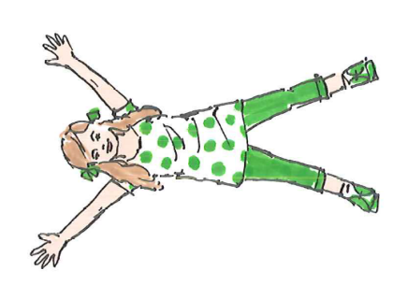
Two-handed skills (bilateral integration) are needed when both hands work together to complete a task. Children can use these skills for:
- 👕 Dressing (buttons, zips, shoelaces)
- ✂️ Using scissors
- 🍴 Using a knife and fork
- ✏️ Writing and drawing
- ⚽ Ball games
- 🧩 Construction toys and puzzles

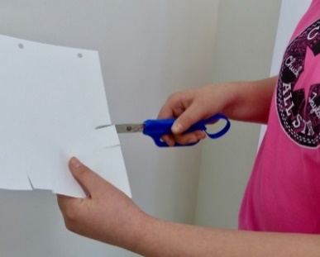
Your child may find it difficult to:
- Hold paper while writing or cutting
- Use scissors
- Fasten clothing
- Catch and throw a ball
- Use a knife and fork together
- Build with construction toys

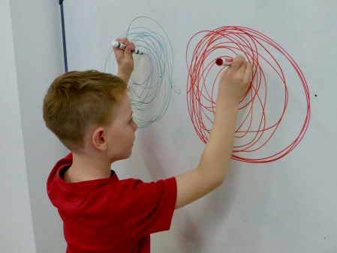
Fun Activities to Try

Big Movements
✅ Star jumps
✅ Animal walks
✅ Marching
✅ Action songs
✅ Clapping games
✅ Climbing frames
✅ Swimming
✅ Ball games using two hands like balloon volleyball

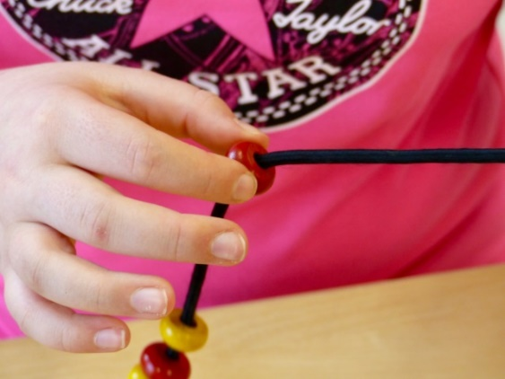
Small Movements
✅ Baking and stirring
✅ Roll and squeeze playdough
✅ Building with construction blocks
✅ Threading large beads
✅ Lacing cards
✅ Using a dustpan and brush
✅ Pouring water or sand
✅ Opening and closing containers

Everyday Practice
Encourage your child to help with:
- Making snacks
- Folding laundry
- Puzzles
- Arts and crafts 🎨
- Turning pages in books 📚
- Opening packets and containers 🎁

Top Tips
⭐ Keep activities fun.
⭐ Practise little and often.
⭐ Praise effort and progress.
⭐ Include practice in everyday activities.

Remember
Children develop two-handed skills through play and daily activities. Regular opportunities to use both hands together will help your child become more confident and independent at home and school.

Children's Occupational Therapy Service
Supporting children and families to develop skills for everyday life.

