

Calming Strategies

Helping Your Child Feel Calm and Well Regulated
Children can sometimes become overwhelmed, anxious, frustrated or highly alert. When this happens they may react by shouting, running away, refusing activities or becoming upset. These reactions are often a sign that your child is struggling to manage their emotions, stress levels or sensory experiences.
When children are very upset, they are unable to think clearly or learn effectively. Helping them to feel calm and safe is the first priority.

Signs Your Child May Be Becoming Overwhelmed
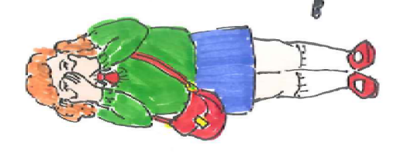
Your child may:
- Withdraw from activities
- Seem restless or unable to sit still
- Have difficulty concentrating
- Find it difficult to listen or follow instructions
- Become more anxious, emotional, irritable, angry or upset

Calming Activities to Try
Type of Activity | Examples
Breathing and Relaxation | • Slow, deep breathing  • Blowing bubbles  • Listening to calming music. Headphones can help to reduce distractions.  • Sitting in a quiet space
Movement Activities | • Wall push-ups  • Chair push-ups  • Stretching  • Gentle forward and backward swinging  • Activities on hands and knees  • Pushing or pulling objects  • Tug of war games
Hand Activities | • Squeezing a stress ball  • Stretching elastic bands around fingers  • Using fidget toys  • Playing with Blu Tack, playdough or therapy putty
Deep Pressure Activities | • Firm hugs. Only use this method if your child enjoys hugs.  • Rolling up in a blanket  • Using a weighted lap pad or cuddling a weighted cushion or teddy
Everyday Activities | • Carrying shopping bags  • Pushing a shopping trolley  • Helping with laundry  • Unloading the dishwasher  • Hoovering or mopping the floor  • Putting out recycling  • Gardening: digging, carrying watering cans and pushing a wheelbarrow
Drinks and Snacks | • Drinking through a straw or sports bottle  • Drinking smoothies, yoghurt drinks or thick shakes  • Eating different types of food like crunchy, soft, salty, spicy
Calm Spaces | • Safe space away from busy environments where your child can calm down before returning to activities  • Tent or den  • Create a quiet corner with cushions or beanbags, favourite books or fidget toys, weighted cushions or blankets  • Soft lighting

Top Tips
✅ Stay calm and use a gentle voice
✅ Look for early signs that your child is becoming overwhelmed
✅ Offer calming activities before things get worse
✅ Build movement and sensory activities into the daily routine
✅ Focus on helping your child feel safe and understood
✅ Remember that every child responds differently

Remember
All children feel overwhelmed from time to time. By helping your child understand what helps them feel calm, you can support their emotional wellbeing, concentration and participation in everyday activities. Small, regular calming activities throughout the day can often prevent stress and anxiety from building up. 😊
Children's Occupational Therapy Service
Supporting children and families to develop skills for everyday life.

