**Sorting, Categorising and Comparison**

Compare, sort, match and classify objects

**Making the Most of Maths**

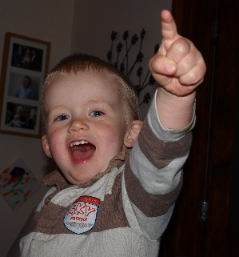

Make collections to sort and compare which include objects that are identical and those of different kinds and sizes. When out on a walk, point things out, cows/lambs in a field, dogs at the park. What breed/size/colour are they? Look at the plants and animals in the garden. Make comparisons relating to size, length, weight and capacity. Use mathematical words to compare amounts ‘**more than,’** ‘**fewer than’**. Have fun in the bath comparing the size of bubbles and the amount of water different cups hold. Sort clothes into winter and summer outfits.

Use your senses to explore the attributes of the world around you. Look for similarities and differences. Complete inset puzzles and match the pictures /shapes. Play with stacking blocks and cups. Put objects inside others and take them out again. Compare amounts, saying ‘**lots**’, ‘**more**’ or ‘**same**’. Help to tidy up. Collect and sort toys and everyday objects into groups. Put cars together, spoons, socks etc. Share books and match the animal with the noise it makes. Help to put away the shopping and talk about what goes in the fridge and what lives in the cupboard.

**3 - 4 years**

Go for a walk and make a collection of leaves, sticks, nuts etc. Group them and then compare e.g., the length of the sticks, which are thicker/thinner. Talk about the trees the items come from, Oak, Horse Chestnut, deciduous trees. Follow your child’s interests and make collections of interest to them. This might be vehicles (trucks/cars), dinosaurs (horns/plant eaters) or animals (land/water). Ask your child to define their own attributes for sorting and classifying. Encourage them to explain their choices, this supports critical thinking and problem solving. Move on to sort texture and sound or by using two attributes.

**Birth – 3 years**

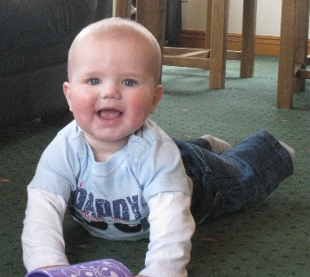

**4 - 5 years**

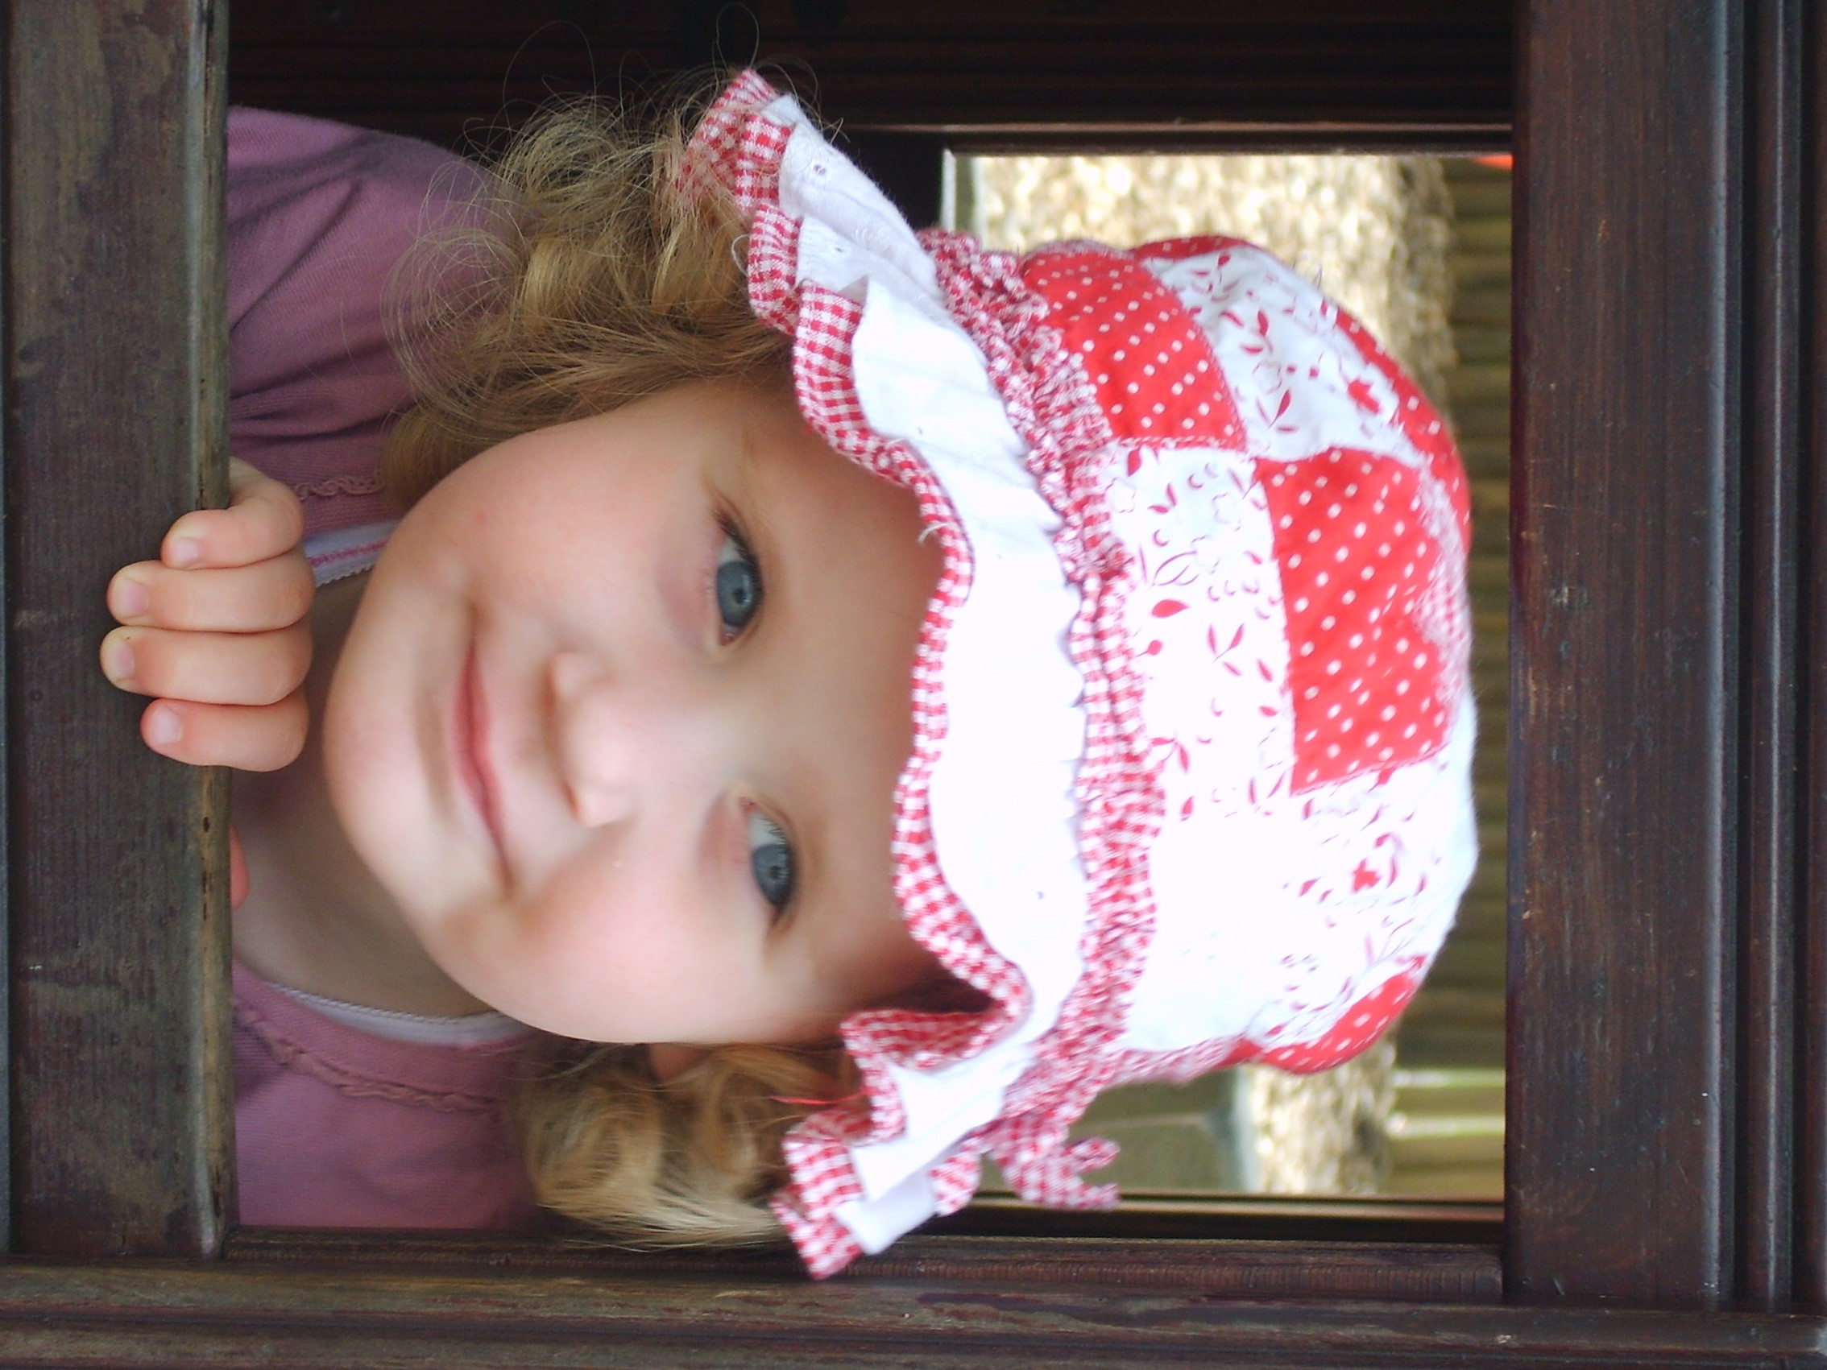

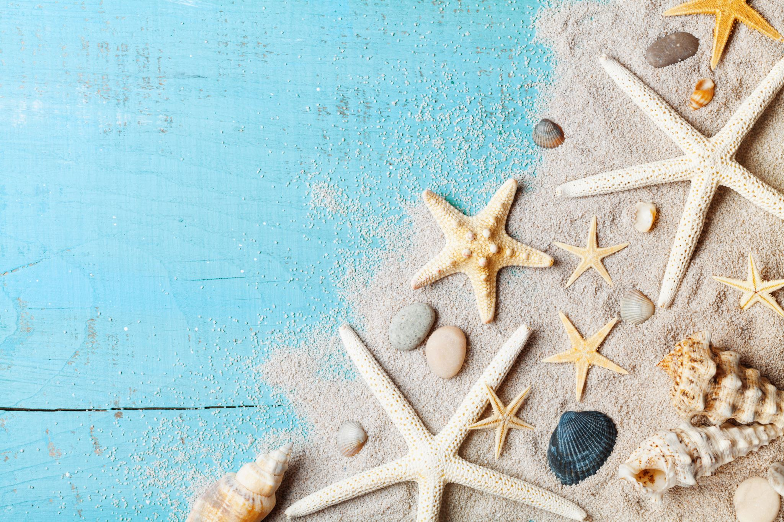

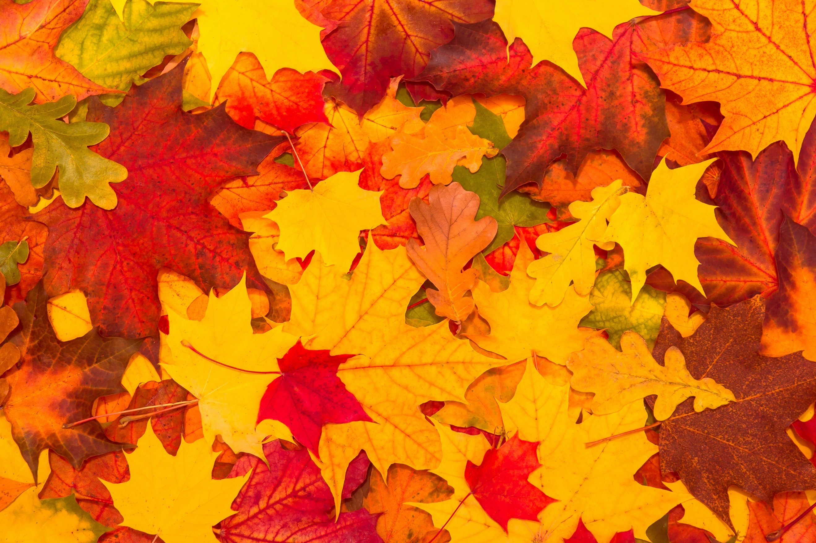

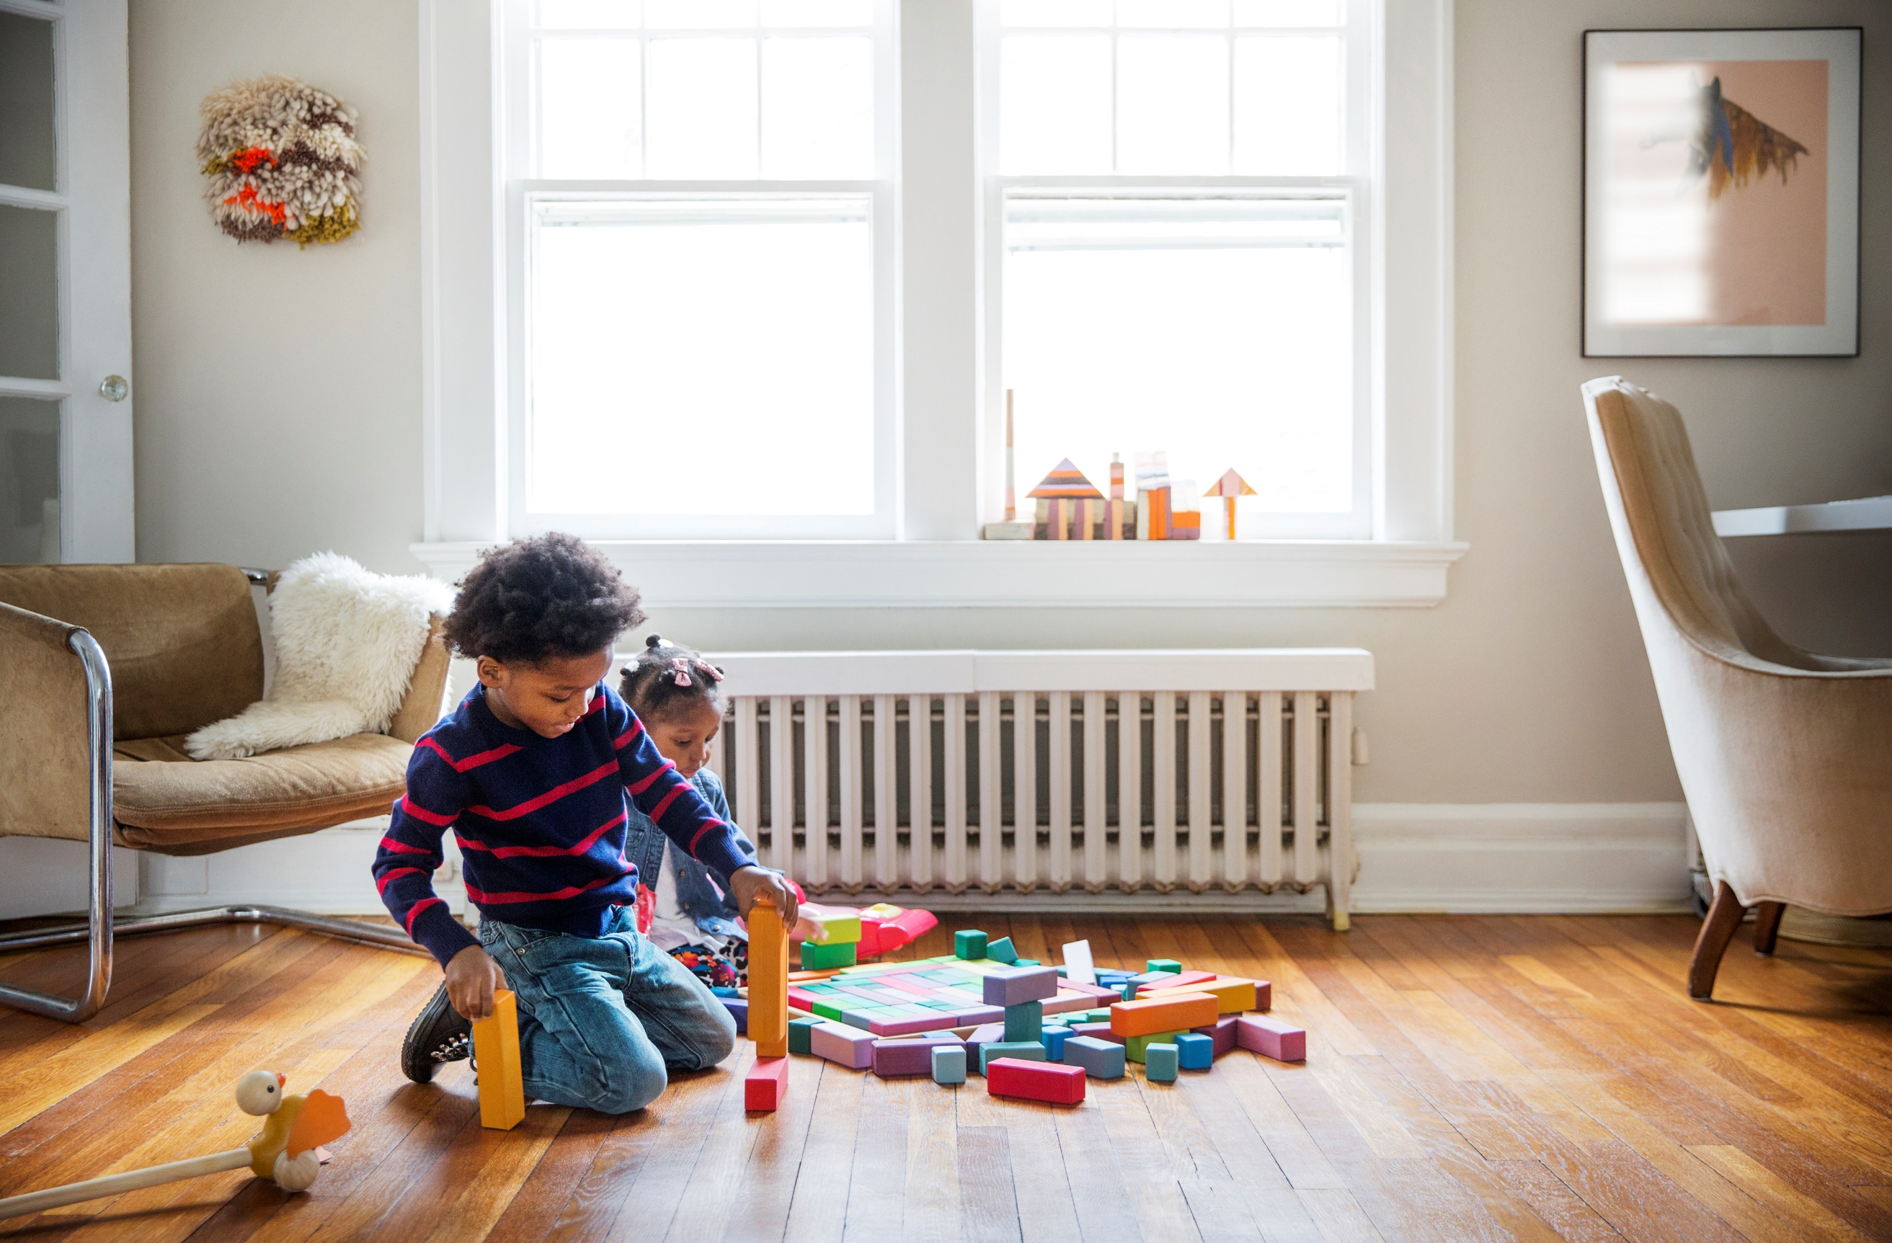

**Mealtimes** –Use cups and saucers, match mats and plates, sort cutlery into sets. Talk about different kinds of fruit and vegetables. Sort by size, shape or colour. Compare with those you are sitting with, who has more grapes or which carrot sticks are the longest. **Keeping tidy** – Keep your real object collections in shoe boxes or gift bags. Take a photograph of the contents and label the box or bag. When tidying up, match the object to the photo. Sort books into categories, fiction, non-fiction, poetry books. Make a set of current favourites, funny books or those that rhyme.

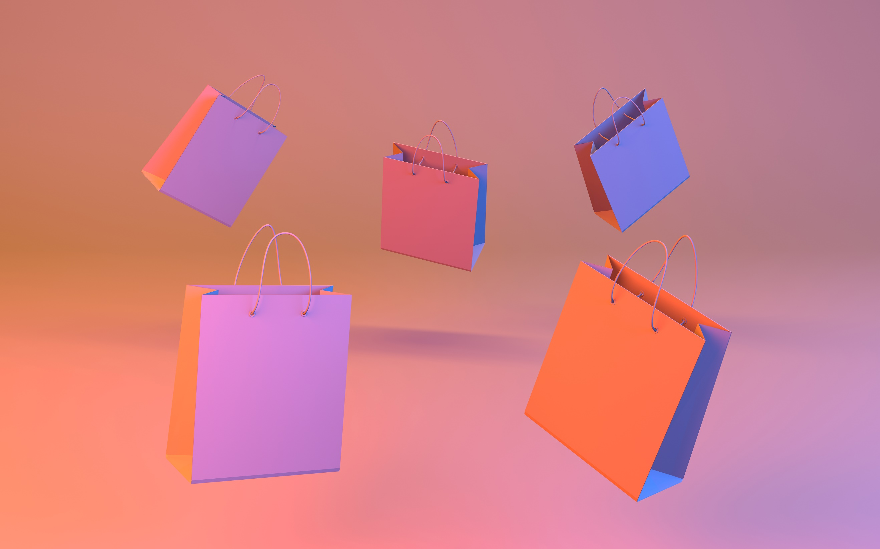

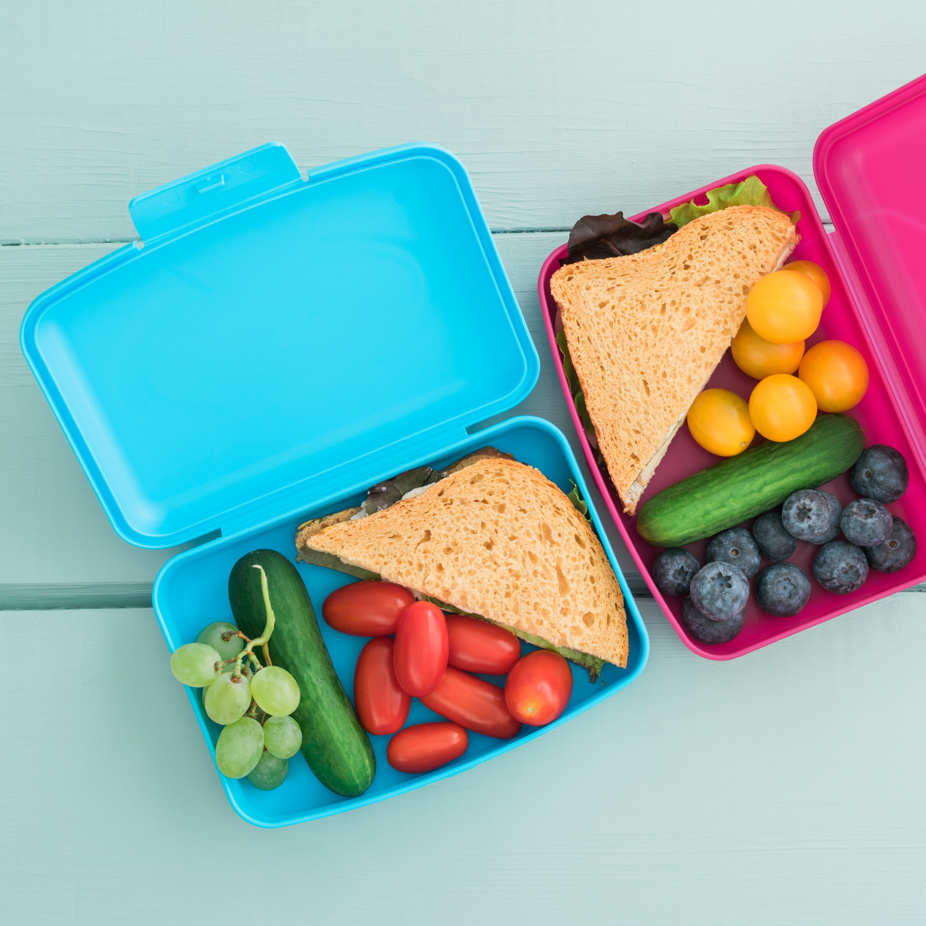

**Sorting and comparing**

**dur**

**during play**



Maths Challenge

Can you sort the cutlery in your house into different sets?

How did you do it?

**Maths Challenge at Home –** lots more ideas in the Cumberland Early YearsMathematics Toolkit[Early Years Maths Toolkit (cumbria.gov.uk)](https://www.cumbria.gov.uk/elibrary/Content/Internet/537/1459/7037/17952/44048142650.pdf)

Provide a variety of resources that will support learning about sorting and comparing. Farm animals of different sizes, shape sorter or post box (you could make your own with a pringles tube), coloured wooden blocks, natural objects like pinecones, leaves, shells or stones. Talk about colour, shape, length, height weight and quantity.

**Sorting during routines**