**Shape**

**Learning about the shapes around us helps to organise visual information and apply what we have learnt using logic.**

**Making the Most of Maths**

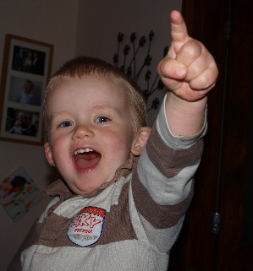

**4 - 5 years**

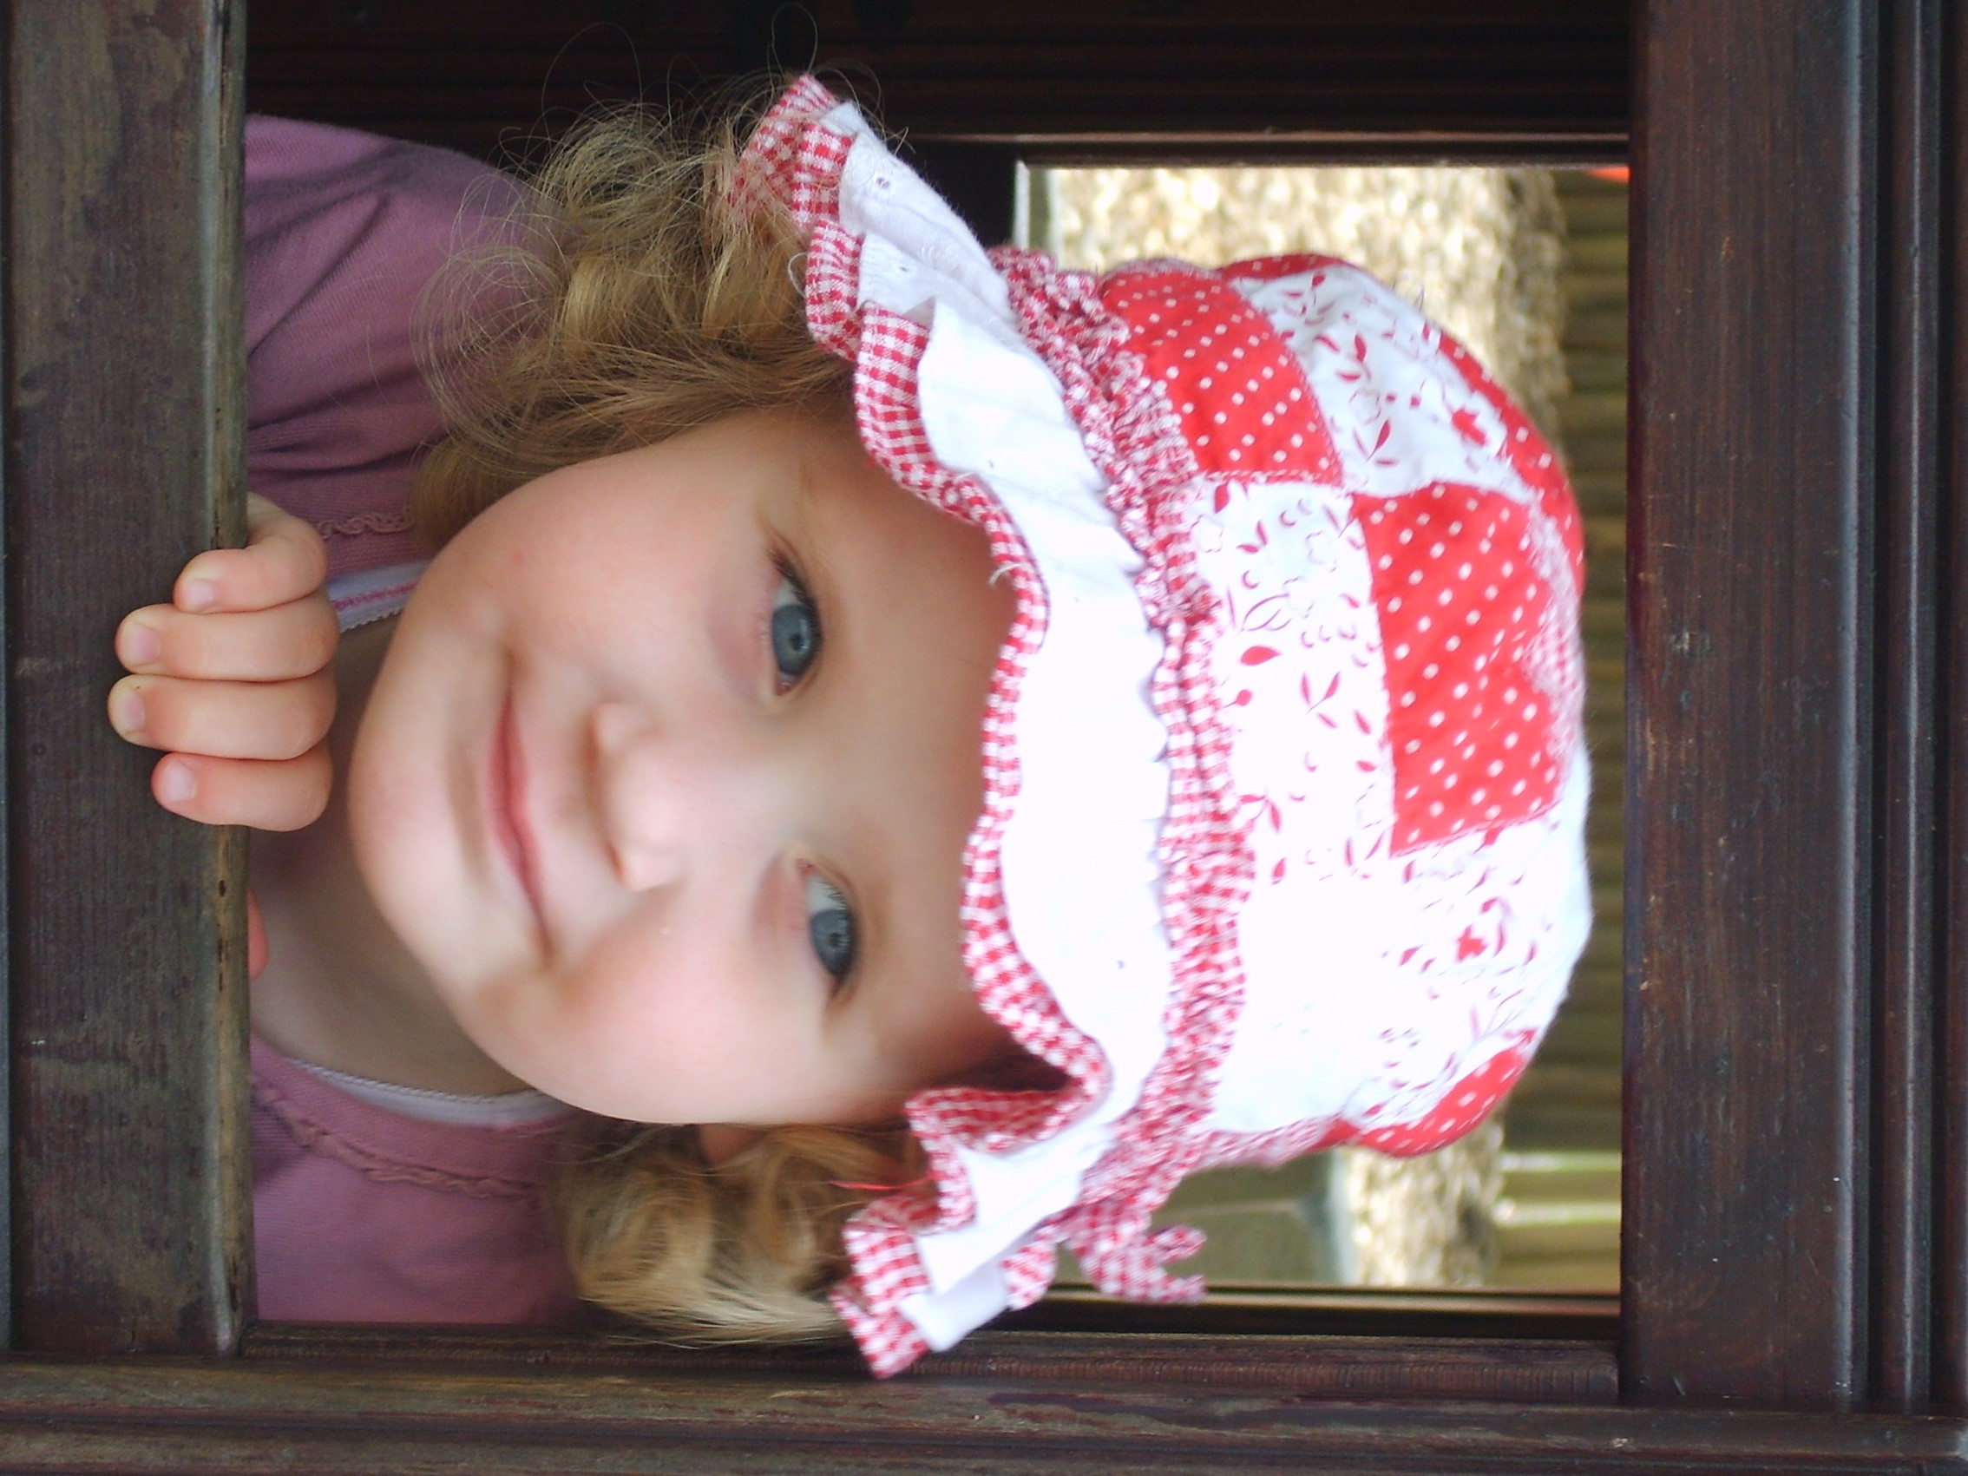

**3 - 4 years**

As children explore, they will enjoy learning about 2D and 3D shapes. Shape sorters will teach them about properties such as sides and corners. Start to use mathematical and informal language as they are playing, such as, **circles, triangles, rectangles, cuboids, spheres , flat, straight, round, curvy**. Encourage problem solving by providing shapes and asking them to build a house, a garage, a farmyard, a railway station…...do they create a secure base or choose triangles for the roof? Use large blocks or boxes to build bigger structures. Can they build one large enough for them to hide in? Provide jigsaws.

Increase the problem solving by adding challenges while children are playing with blocks. For example, ask if they can add a bridge, a ramp or a staircase. Provide shapes that fit together and shapes that do not to highlight different properties and encourage children to choose the best shapes for the task. Encourage children to persevere and talk about how they are using different shapes. Make squares out of triangles or sort shapes. For example, can you put all the shapes with straight sides together, shapes with four corners, shapes that are 3D? Introduce more 3D shapes and more complex jigsaws.

**Birth – 3 years**

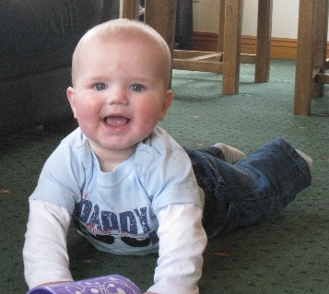

Babies will use their mouths to explore from around three months old. They will learn about shape by doing this. Provide different shaped and textured objects that are safe for them to put in their mouths. The wider the variety the more they will learn. As they get older, they will love holding shaped bricks and cups and having a go at staking them. Help them to build up towers and knock them down! Use new words such as **‘up, down, through, on top of’.** Inset jigsaw puzzles are a fantastic way of them learning about shapes and matching.

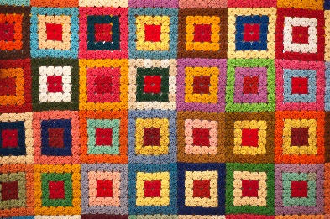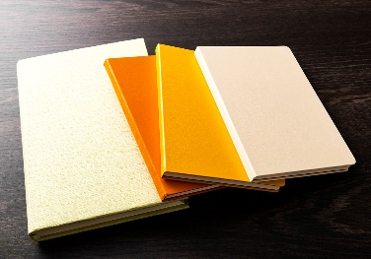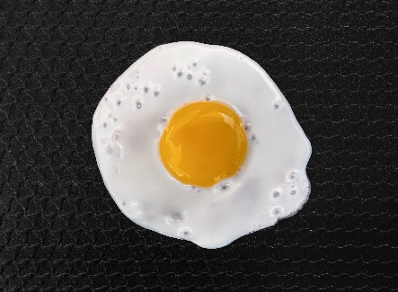 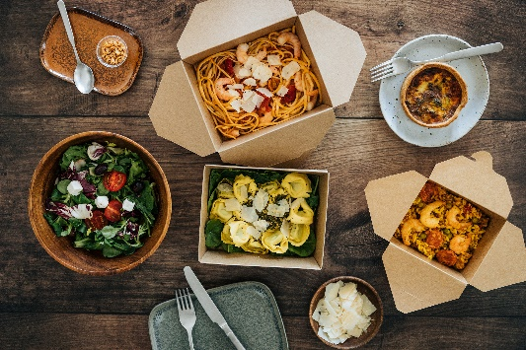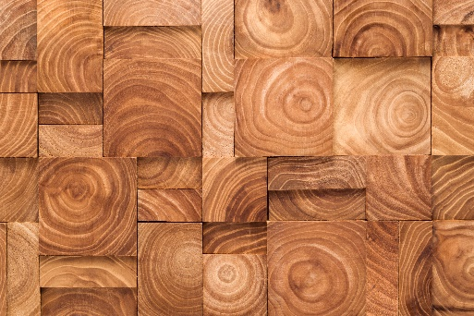

Can you find something that is a square shape in your house?

Can you find something that is a rectangular shape in your house?

Can you find something that is a circular shape in your house?

**Maths Challenge at Home –** lots more ideas in the Cumberland Early YearsMathematics Toolkit[Early Years Maths Toolkit (cumbria.gov.uk)](https://www.cumbria.gov.uk/elibrary/Content/Internet/537/1459/7037/17952/44048142650.pdf)

Provide a variety of resources that will support learning about shape such as 3D blocks, jigsaws, a variety of boxes, stacking cups, balls, tangrams.

Introduce shape language and challenge in dough activities, printing with paint, skittles, building dens, using clay, treasure baskets, railway, road tracks.

**Mealtimes** – Use shape names to describe food such as oranges and pizzas. Make a shape picnic together. Can you cut your sandwiches into triangles or use shape cutters to change the shapes? Stack pans, use cups and saucers, match mats and plates.

**Keeping tidy** – Provide appropriate storage, for example, make tidying blocks and bricks into boxes a game by providing exact storage with no spaces. Arrange some storage by shape, for example all the spheres in one basket, all the flat rectangles in another.

**Shape during play**

**Shape during routines**