**Shape Properties**

**Children understanding the properties of shapes will help them to develop their special awareness, recognise pattern and solve problems.**

**Making the Most of Maths**

Use words such as **side, corner, point, face, smooth, tip, flat, round, curvy, top and bottom.** Place some 2 and 3 D shapes in a bag. Feel them and describe them without taking them out of the bag. Can you guess the shape? Can you spot the same shape but in a different position? Using cardboard, cut out 2 sets of different shapes, make a pattern with one set. Cover the pattern and see if you can make the same pattern with the second set of shapes without looking. Can you select the right shape for a purpose such as a trunk for a model elephant or the right shape for dinosaur’s scales? Can you use trial and improvement? Can you solve more complex jigsaw puzzles. Inside and out create marble runs and obstacle courses. Use phrases such as **turn round, on its corner, from above**. Begin to learn the names of 3 D shapes and understand not all shapes have a name. What word would you use to describe the shape of a cloud or a puddle? Can you be creative and make up your own words!

**4 - 5 years**

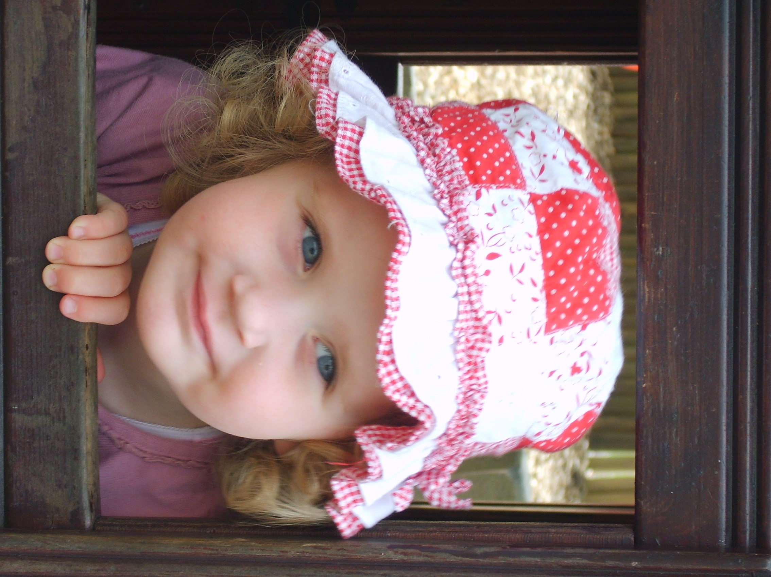

Notice and talk about the properties of shapes as you are out and about. Acorns fitting into cups, stones on the path, some big some small. Can you name some shapes? Circle, square, triangle, rectangle. What shape is the puddle? Can you change its shape by splashing in it? When looking at houses use words such as **slanty and pointy.** Using blocks, can they select the best one to build a bridge? Use words such as **over, too large or too small.** Can they use bricks to make a fence to keep animals in? Use words such as **over, next to, besides.** With a blind fold on can they name the 2 D shapes just by feeling the properties?

Face . corner, shape names blind fold / challenges playdough to change shapes bags – smaller shapes into larger.

**3 - 4 years**

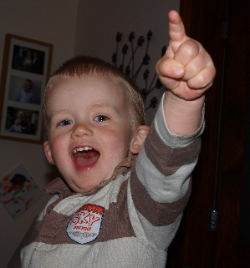

Ensuring it is safe, provide different shapes for your baby to explore using their mouth. Use words such as **round** and **pointy**. Provide shape sorters and stacking bricks. You can make these out of cardboard boxes and use bricks of different shapes to match the holes. Use words such as **inside, bigger, smaller**, and **fits.** Talk to older children about the differences between shapes and sizes. When playing with shapes use words such as **round, though**, **on, giant, small, long, short**. Provide lots of inset jigsaw puzzles and help your child predict if the pieces will fit. Use words such as **turn** and **too big**.

**Birth – 3 years**

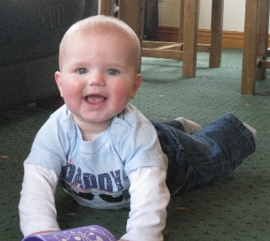

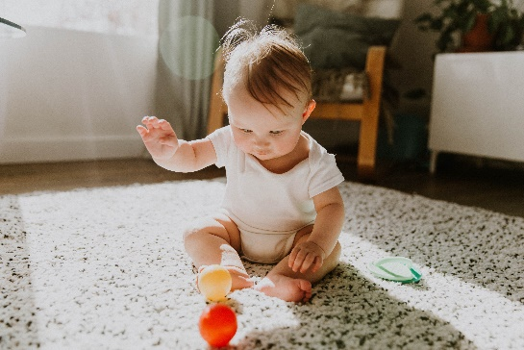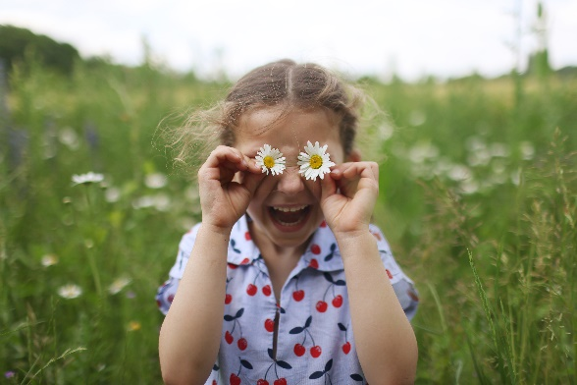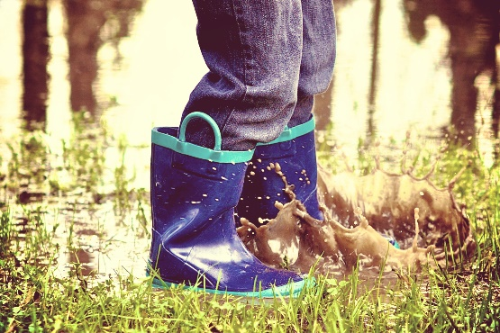

**Maths Challenge at Home –** lots more ideas in the Cumberland Early YearsMathematics Toolkit[Early Years Maths Toolkit (cumbria.gov.uk)](https://www.cumbria.gov.uk/elibrary/Content/Internet/537/1459/7037/17952/44048142650.pdf)

Can draw a shape and fill it with

different shapes?

Can you find shapes that fit together

to make a new shape?

**Explore**

**Change shape**

**Choose shape for a purpose**

**Shape properties during play and routines**