**Making the Most of Maths**

**Position**

**Position is the space occupied by an object with respect to another object.**

Encourage the use of language, **in front of**, **behind**, **before** and **after**, **in a line**. Give directions during play or routines “stand behind Sue and get in a line”. “After Sue it’s Chris’s turn”. Draw a map of your route to nursery or school alternatively read a book like ‘Rosie’s Walk by Pat Hutchins and discuss the position, direction and movement of Rosie as she goes on her adventure.

Use wooden blocks and any other household materials to hand to build bridges, houses/barns and enclosures. During play and exploration use the language of position and direction in context, “the car is (**in**, **on** or **under)** the bridge” or “the horse is (**beside**, **next to**) the field or **between** the gate and the tree.” Support children to persevere with jigsaws. Try hovering a piece over the hole and move it around to match the size and shape until it fits.

Support your baby to be aware of its own body during ‘tummy time’ and through gentle massage. Place objects on the floor just out of reach or on cloth that your baby ran reach out and grab to pull towards themselves. Support the physical experience of position by using spatial words as part of your daily routine, up, down, in, out. Play hide and reveal games like ‘Peek a Boo’ or using objects.

**4 - 5 years**

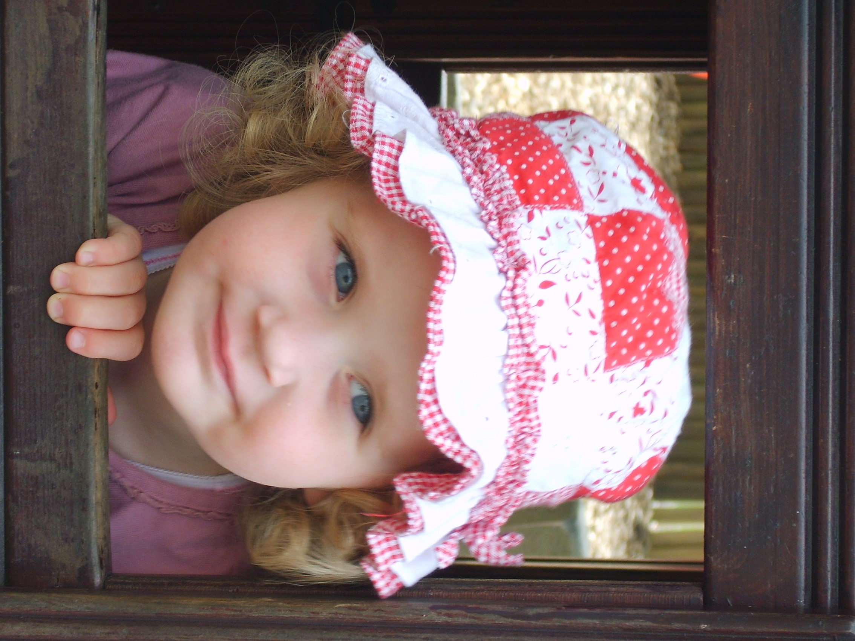

**3 - 4 years**

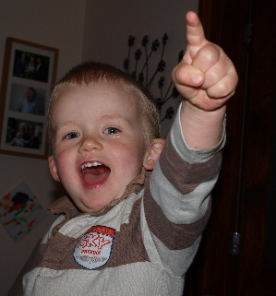

**Birth – 3 years**

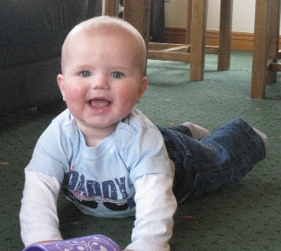

**Position during routines**

**Position during play**

**Enacting-** Act out your own version of well-known stories where characters negotiate routes and obstacles, for example, 'We’re Going on a Bear Hunt'. Use small world play figures and play mats to create real life scenarios to talk about.

**Positional language-** play ‘Simon Says…’ and adapt the instructions to include directional instructions. Look at things from different perspectives. Say what you see.

**Transition times-** Lining up or moving from one place to another lends itself to talking about positional language. Who are you stood **next to** or **in front of** etc?

**Washing hands-** Turn the tap ‘Lucy lefty’ to loosen and start the water then ‘righty tighty’ to stop the water.’ Pick up the soap that is **next to** the tap. Put your hands **underneath** the running water.

**Mealtimes-**Talk about the position of the food on the plate and where the cup and cutlery are. Do you want peas **on top** of your mash or **next to** it?





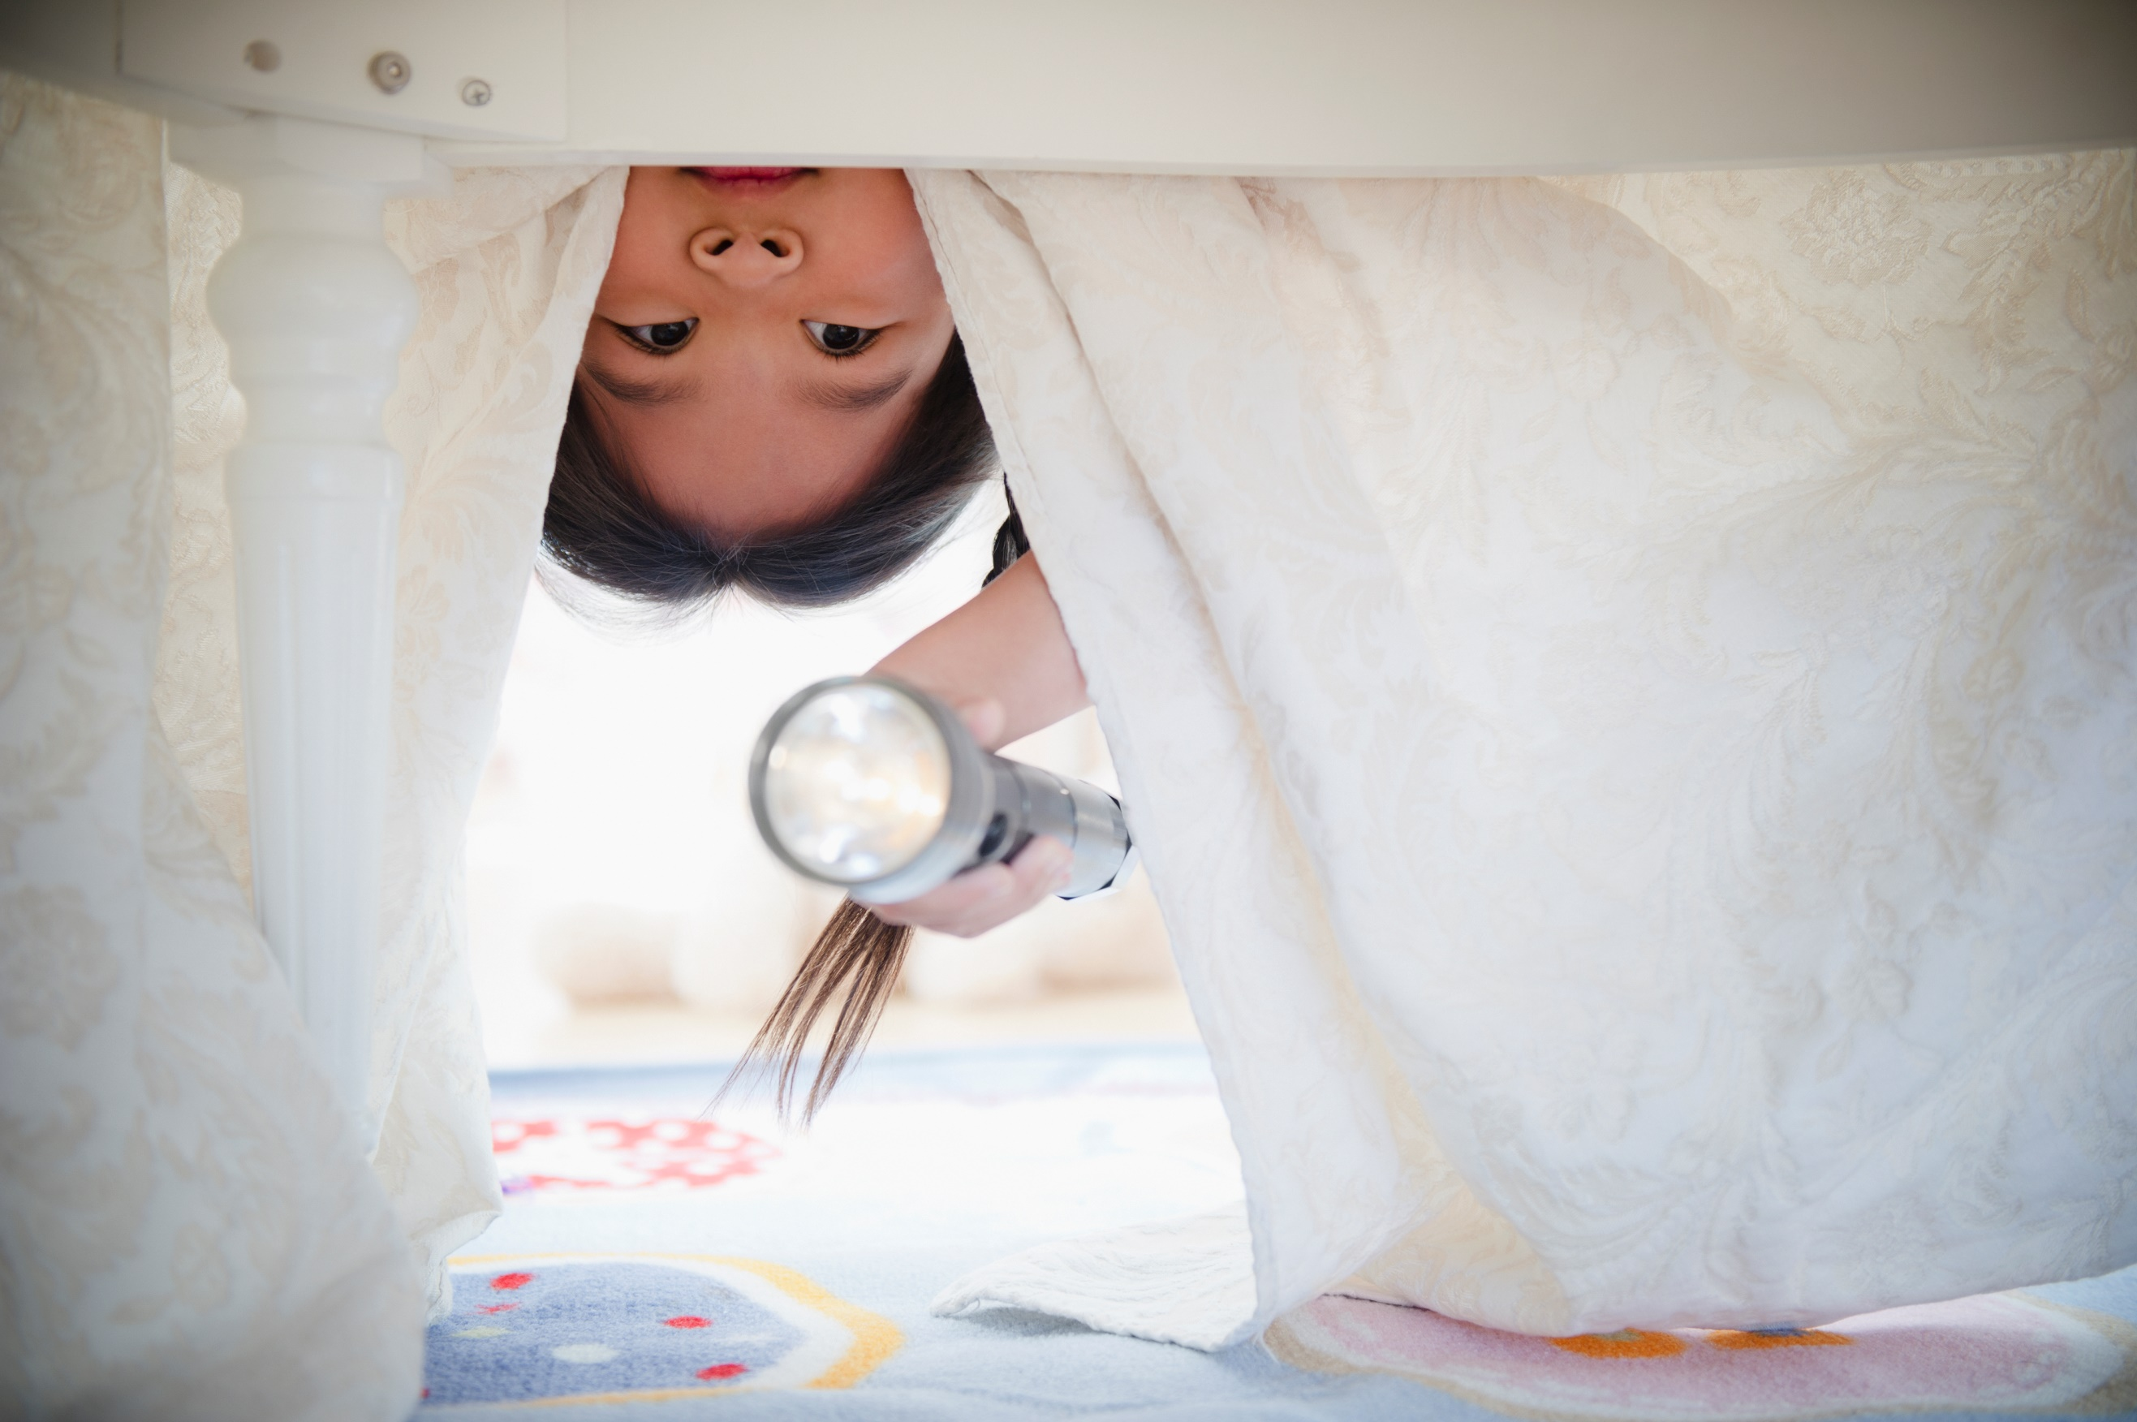

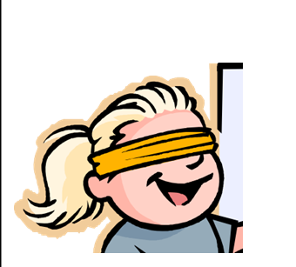

Ask your grown up to blind fold you.

Listen to their instructions and see where you end up!

**Home Maths challenge –** lots more ideas in the Cumberland Early YearsMathematics Toolkit[Early Years Maths Toolkit (cumbria.gov.uk)](https://www.cumbria.gov.uk/elibrary/Content/Internet/537/1459/7037/17952/44048142650.pdf)