**Measures - Time**

**There are lots of opportunities for children to learn about time throughout their day.**

**Making the Most of Maths**

Use words such as, soon**, after, before, later.** Use pictures to order events showing the passage of time, such a seed growing into a plant, a baby growing up. Can they predict what happens next in a story? Read them stories about the past and using pictures can they tell which car / house / clothes / food are from the past and which the present? Read **We’re Going on A Bear Hunt** and discuss the sequence of events and time passing. About a week before, can they count down in sleeps the number of days to an important event. How will they record this? Can they find the biggest and smallest number on a clock face? Can they work out a way of finding out which is the fastest push along car and how to record this?

**4 - 5 years**

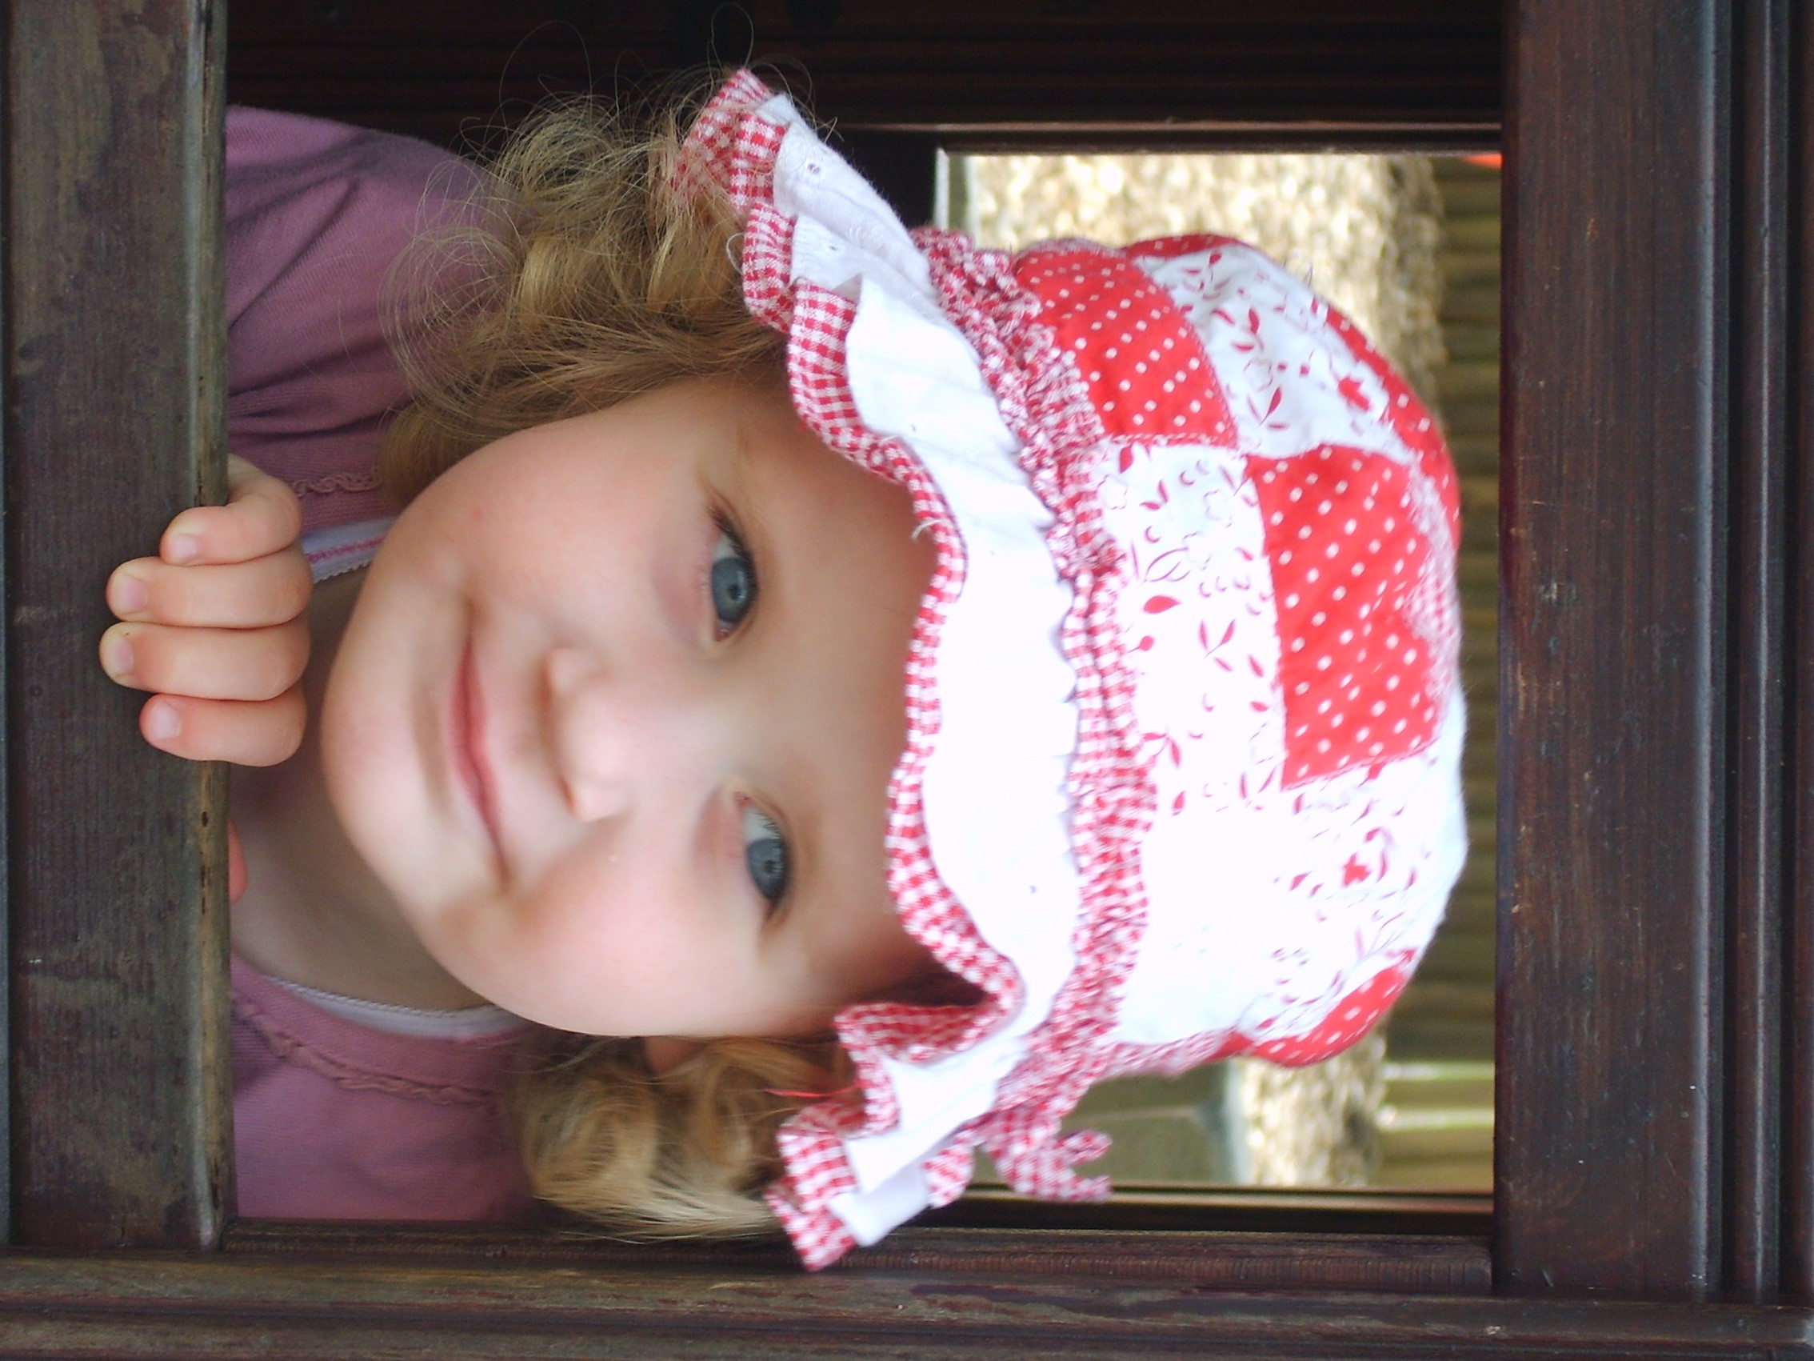

Throughout the day you can use more words that relate to the passing of time. Words such as , **morning, afternoon, evening, night-time, earlier, later, too late, too soon, in a minute**. Read stories such as **The Gingerbread Man**. Ask what they think will happen next and can they remember the order of events in the story? Anticipate when events will happen through the day such as mealtime and visits. Discuss with children that some things will happen now and some another time such as holidays and birthdays. Use different timers to measure how long it takes to jump ten times, run round the field, do a jigsaw….

**3 - 4 years**

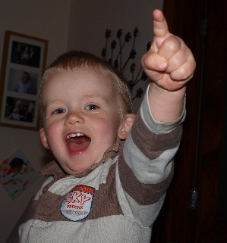

Young children will gradually start to lean about the passage of time. You can draw their attention to it by using words during the day such as, “ We will read a story **after** breakfast.” As they get older, they will begin to understand things need to happen in a certain order to work well .Such as, “**First** we will find the ball **then** we will throw it for the dog.” Naming routines will help them to understand the passing of the day as they realise events happen at the same time. Breakfast, lunchtime, teatime, bathtime , bedtime. Sing rhymes with a sequence such as, [Pat-a-cake - CBeebies - BBC](https://www.bbc.co.uk/cbeebies/watch/the-baby-club-pat-a-cake)

**Birth – 3 years**

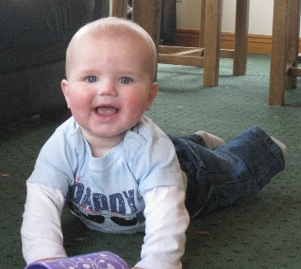

**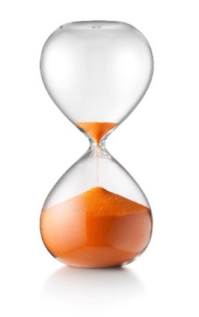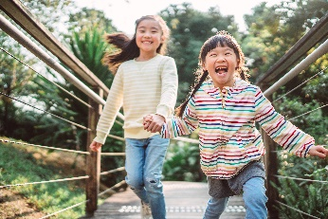

**Time during routines**

**Mealtimes -** Washing hands can teach children about order and routines. First, we use the soap then we rub our hands together. Children can follow instructions when they are cooking and use the timer to make sure the cake is cooked. First, we have our pizza then we eat our apple.

**Getting Dressed -** Talk about the order of getting dressed. First our socks then our shoes.

**Our day -** You could use pictures to make a daily or weekly timetable showing important events such as going to the park or visiting Nanna.

**Games** – Learn how to play **What’s the Time Mr. Wolf**. Play running games and time how long it takes to finish the race. Try timing an obstacle course. How will your record how long it takes?

**Changes** – provide lots of plant pots, soils, seeds, and watering cans. Can you plant seeds to grow and see the changes over time?

**Clocks** – provide old clocks that can be safely taken apart. Have they got cogs? Do they tick? Do we use them to tell the time now? Can you make sundial from a paper plate and a pencil. How will you know the time is correct?

**Maths Challenge at Home –** lots more ideas in the Cumberland Early YearsMathematics Toolkit[Early Years Maths Toolkit (cumbria.gov.uk)](https://www.cumbria.gov.uk/elibrary/Content/Internet/537/1459/7037/17952/44048142650.pdf)

How many ways of measuring time can you find in your house?

How many ways of measuring time can you spot on a walk?

**Time during play**