**Measures - Size**

**There are lots of opportunities for children to learn how to measure size throughout their day.**

**Making the Most of Maths**

Use **Goldilocks and the Three Bears** story to talk about size. Sing the song together. [When Goldilocks went to the house of the bears - BBC Teach](https://www.bbc.co.uk/teach/school-radio/nursery-rhymes-when-goldilocks-went-to-the-house-of-the-bears/zbkrf4j) Use the words **huge, small, tiny.** Can you find a huge, tiny, small spoon, bowl, chair , bed, bear in your house? Set challenges by asking “ Can you find a larger plate?” “Can we make the apple smaller?” Introduce the idea of exactly by asking “Are the spoons exactly the same size?” Can they find their favourite toys and arrange them in order of size finding the smallest and the biggest, the **tallest and the shortest**?

Use the **Goldilocks and the Three Bears** story to talk about comparing size. Sing the song [When Goldilocks went to the house of the bears - BBC Teach](https://www.bbc.co.uk/teach/school-radio/nursery-rhymes-when-goldilocks-went-to-the-house-of-the-bears/zbkrf4j) Introduce the concept of **medium** sized. Use comparative language “ than.” Set some challenges such as “ Is the blue bike **longer than** or shorter than the red bike?” Ask for reasons why they have made that decision and can they test their predictions. How would they do it ? What are the different ways you could measure the bikes ? Provide objects that are small yet heavy, tall yet thin, large yet light.

Babies love to reach out and grasp objects of assorted sizes when they are playing. Comment on the size of objects using **big and small**. As they grow give them big and little versions of the same objects such as spoons and balls for them to compare. Comment using more size words such as **huge, little, tiny and enormous.** Sing songs and rhymes showing size. Make up your own rhymes such as “ Mummy is big, grandpa is huge, baby is small.” Make gestures to show the sizes.

**4 - 5 years**

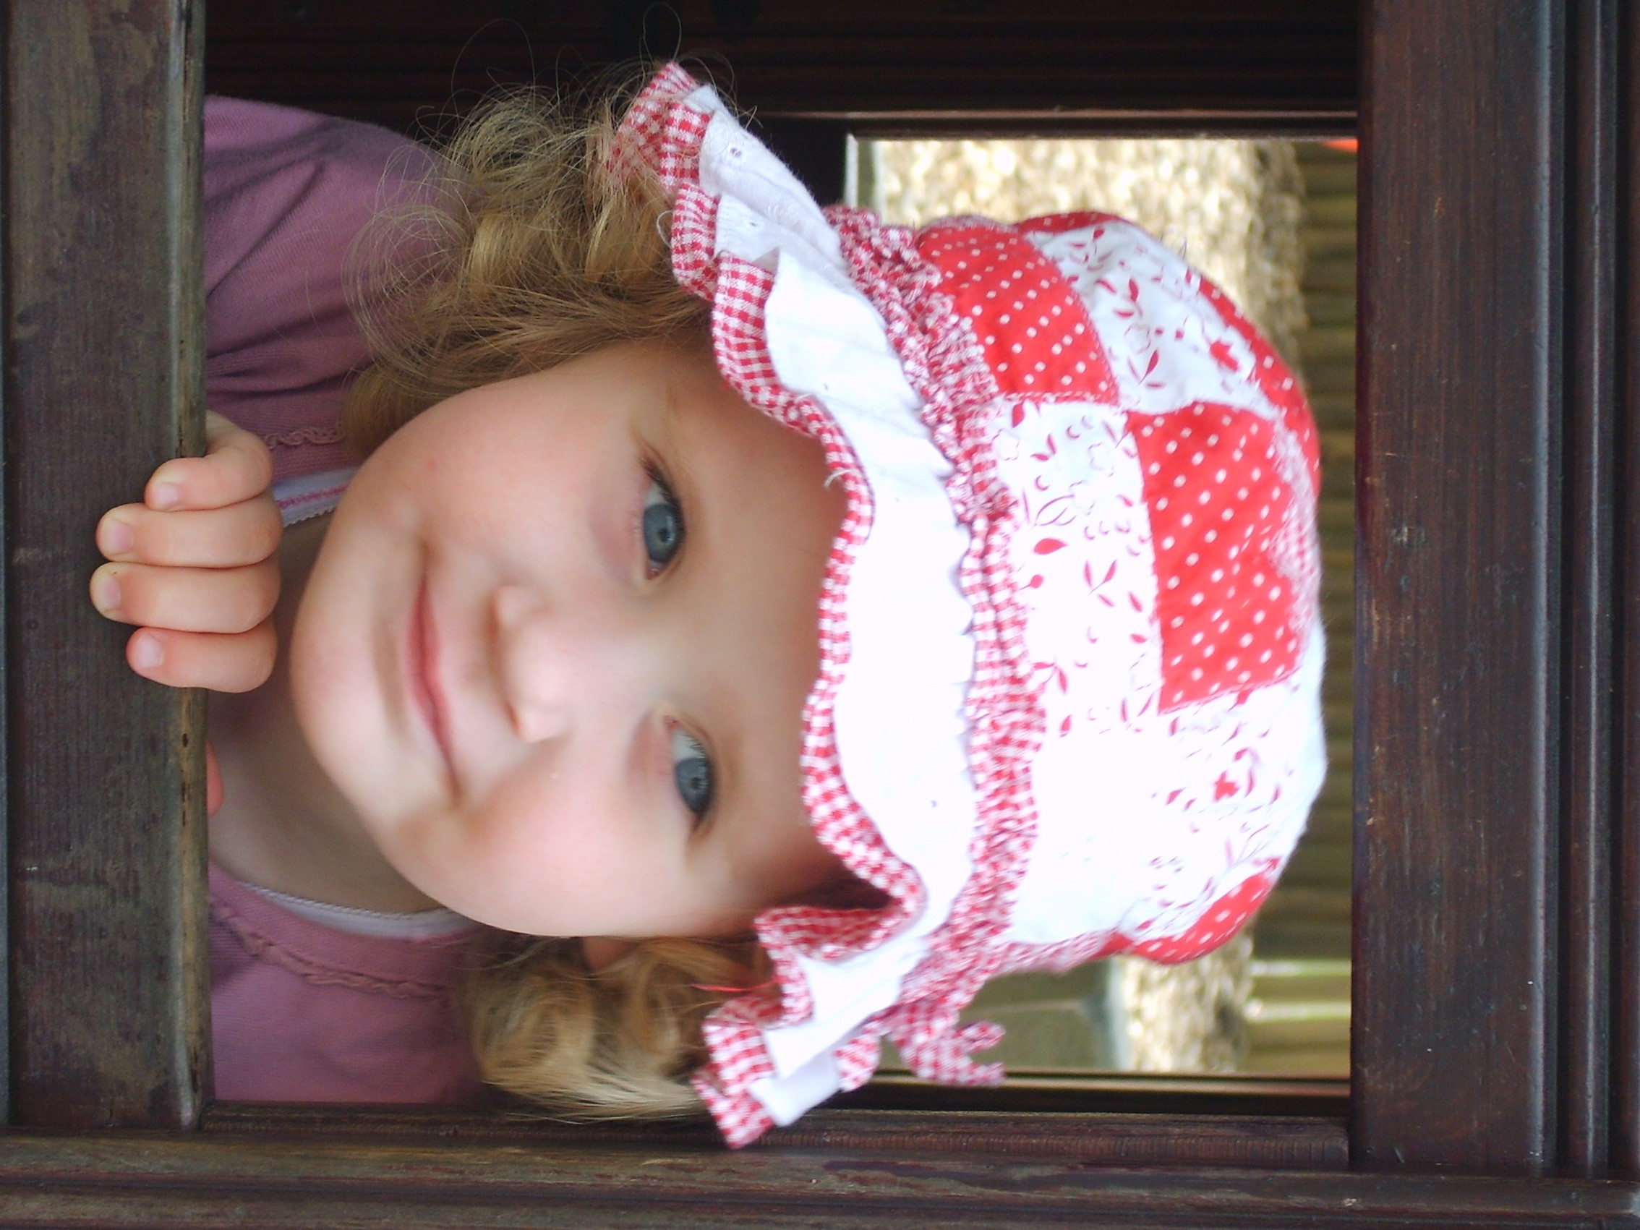

**3 - 4 years**

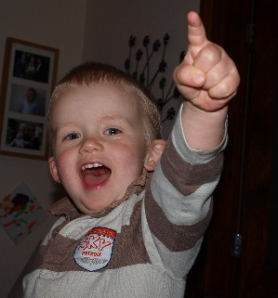

**Birth – 3 years**

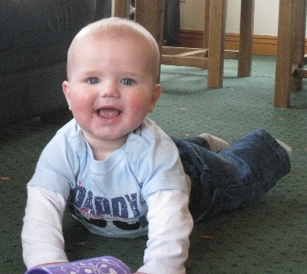

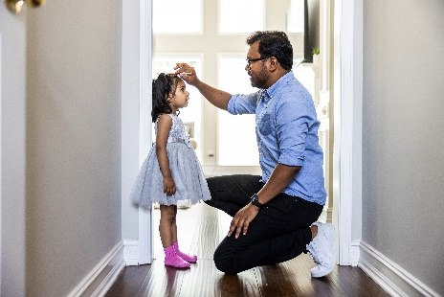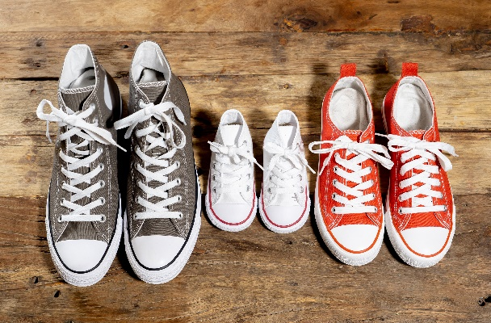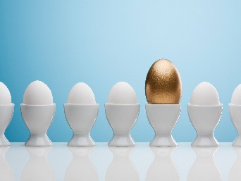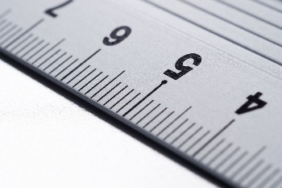

Can you collect some sticks? Which is the longest?

Which is the shortest?

Can you put them in order of their length?

**Maths challenge at home-** lots more ideas in the Cumberland Early YearsMathematics Toolkit[Early Years Maths Toolkit (cumbria.gov.uk)](https://www.cumbria.gov.uk/elibrary/Content/Internet/537/1459/7037/17952/44048142650.pdf)

**Getting dressed** – Compare the sizes of socks and shoes, order them from smallest to biggest. Hang clothes on the line in order of length.

**Mealtimes –** who has the biggest spoon, bowl, plate? Are there any exactly the same or any longer than another?

**Shopping** – Can you find the longest carrot?

**Measuring height –** This can be a new routine you create. Measuring the family against the door on a height chart.

**In the park** - How many footsteps to the swing? Find the tallest tree, the biggest stone, the tiniest leaf.

**Size during routines**

**Size during play**

Provide a variety of toys and objects of varied sizes for children to play with where children will naturally learn about size. Ensure some of the objects are identical apart from their size. Provide boxes and containers of different sizes that will fit into each other. Provide rulers, tape measures, sticks, measuring wheels for children to investigate with. While they are playing talk to them about size. For example, which is the tallest teddy and how do they know?