**Making the Most of Maths**

**Measures - Capacity**

**Capacity is the amount a container can hold. Exploring this will help develop spatial awareness and mathematical thinking skills.**



Using the same practical activities, as with younger children challenge and increase older children’s understanding by asking questions and finding out the answers together. Use the comparative language of **more than/ less than.** Have guesses first such as “I think the jug holds more water than the bowl, what do you think? How could we find out?” Embed their counting skills by counting how many marbles will fill an egg cup to the top? Use the language **empty /full / half full** while they play with containers. Make up new words together to the I’m a Little Tea to tune. How about- I’m a little bucket short and squat, can you fill me to the top? When I’m getting full up you can stop, hurry up and off I hop. Sometimes the sillier the better!

**4 - 5 years**

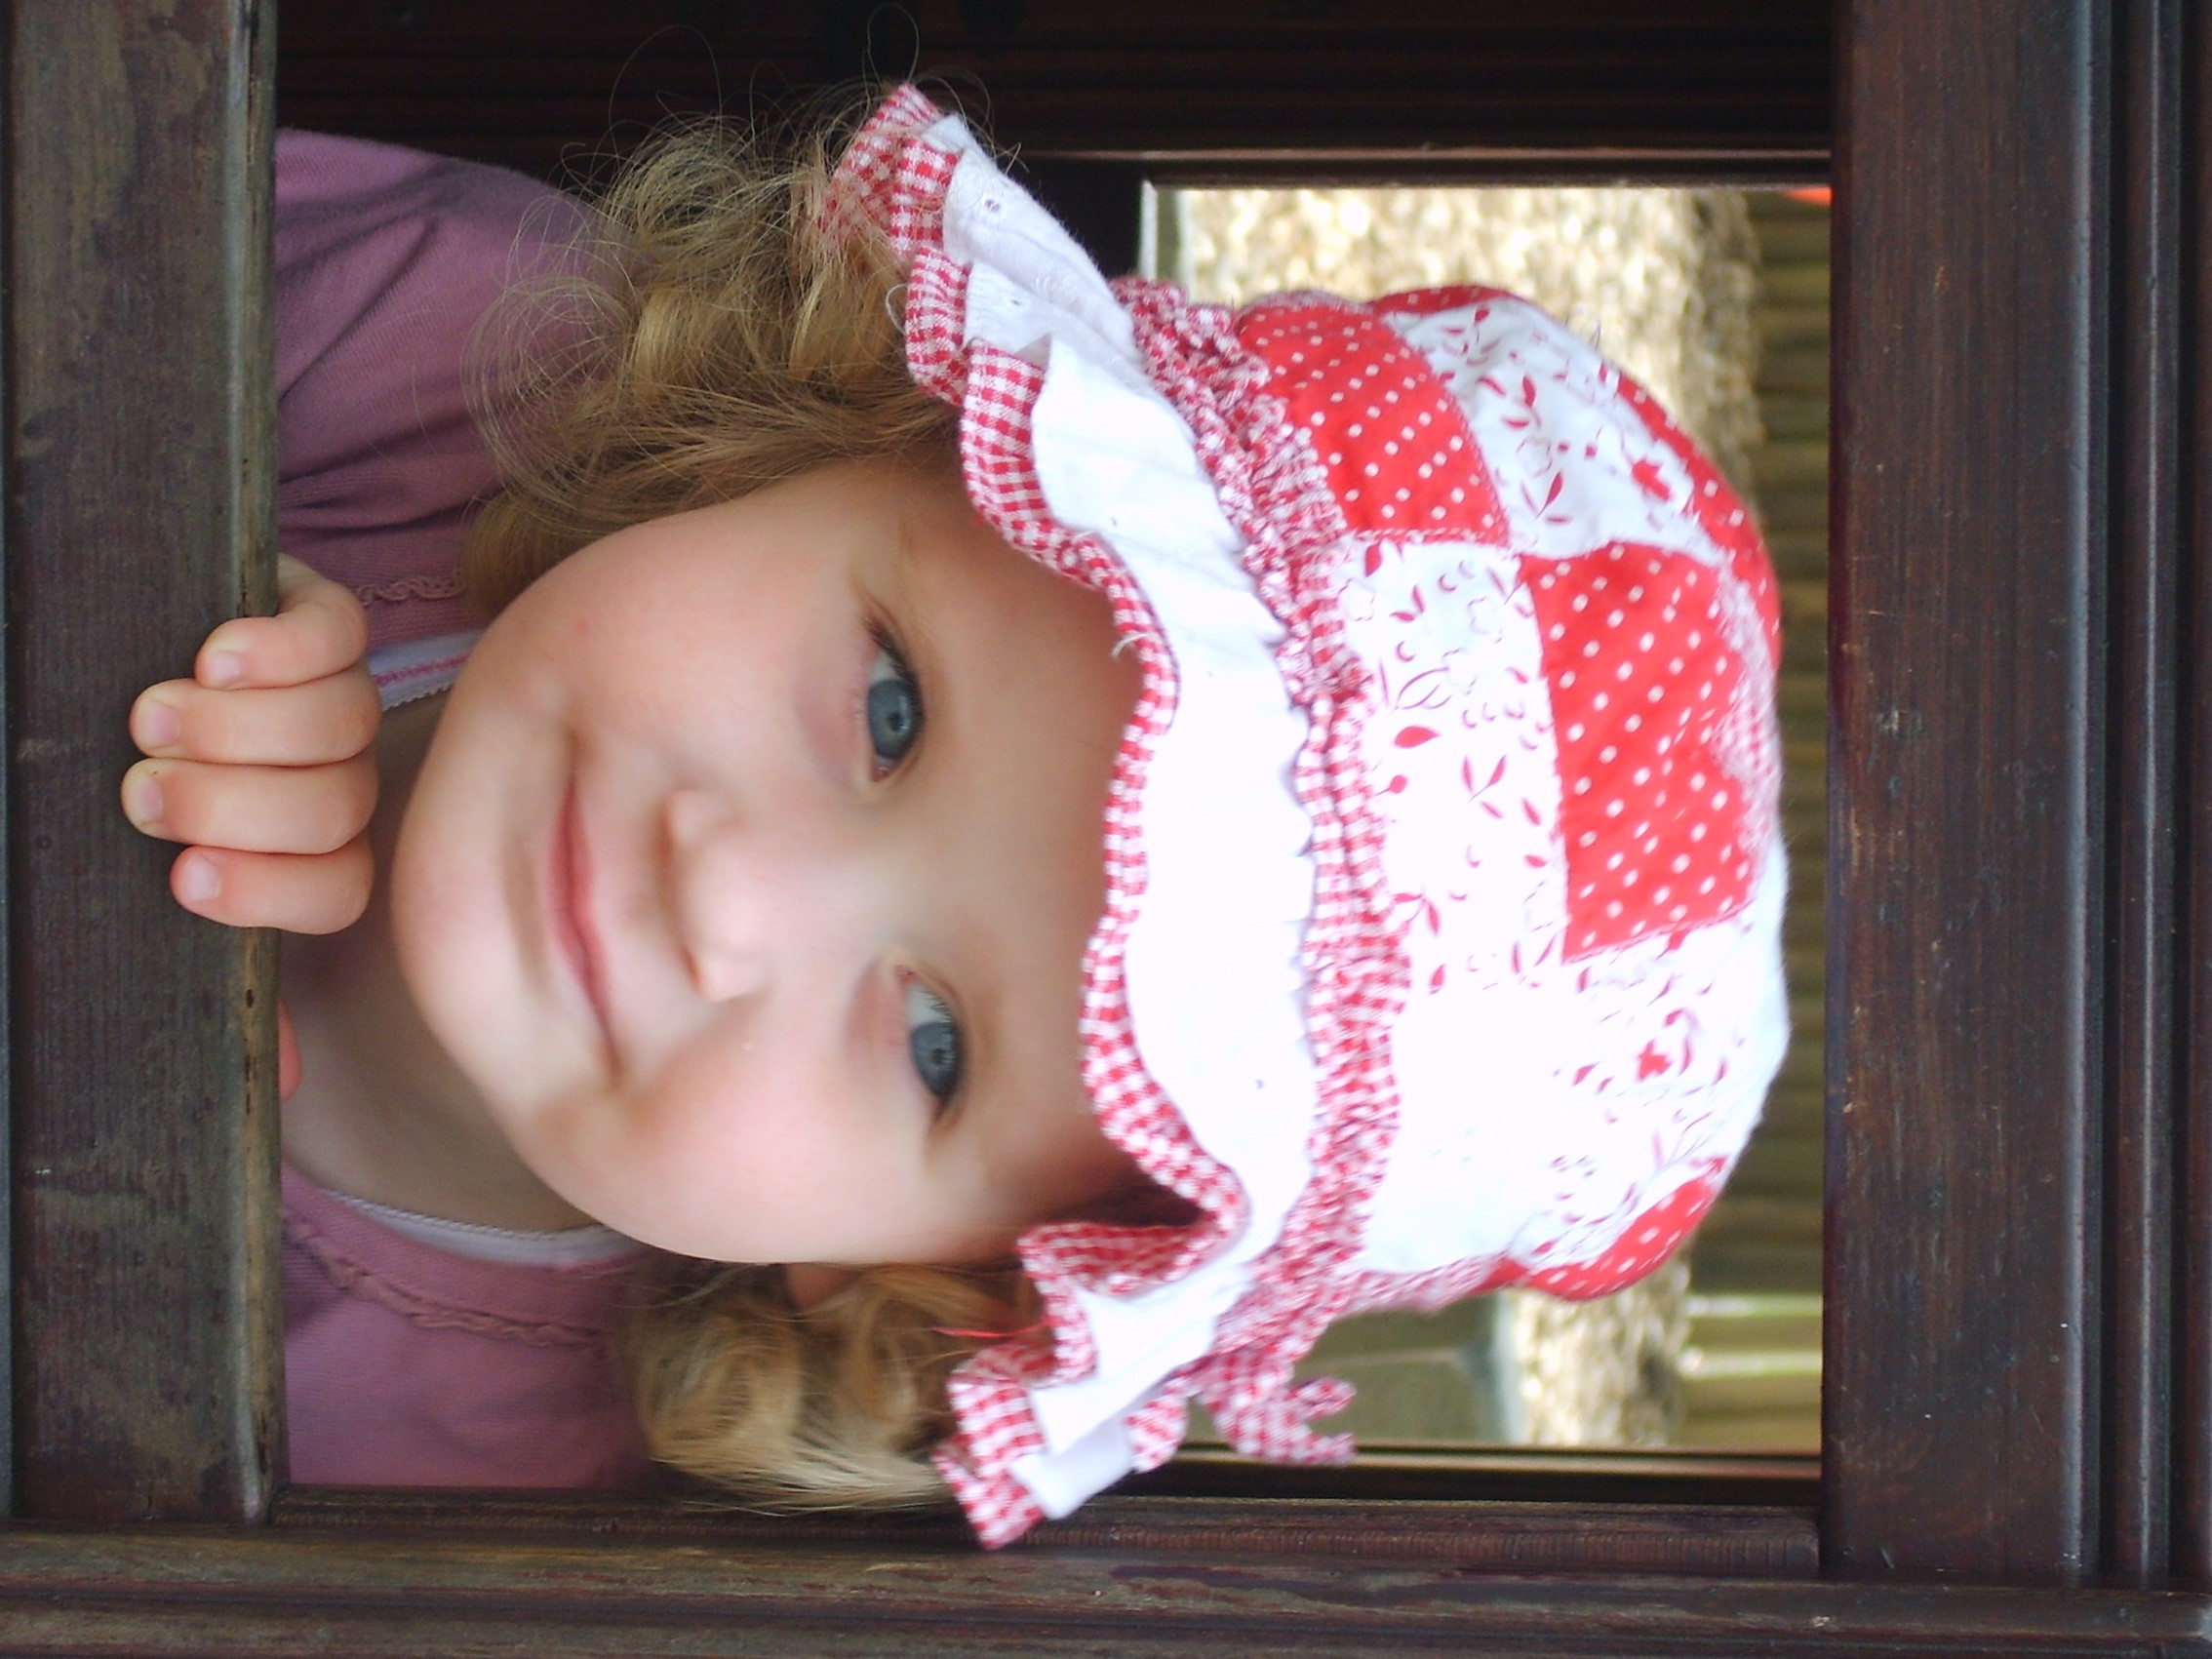

Increase older children’s understanding by providing containers that allow them to explore concepts such as smaller containers filling up larger ones. You could give them lots of ways of filling such as water, sand, pebbles, fir cones, flour, cloth…. Give them scoops and help them count how many scoops or spades will fill a bucket. Having a go lots of times will increase their learning and confidence. Use the rhyme [I'm a Little Teapot - CBeebies - BBC](https://www.bbc.co.uk/cbeebies/watch/something-special-little-teapot) to explore comparing capacity – how many teacups can the teapot **fill** to the top ?

**3 - 4 years**

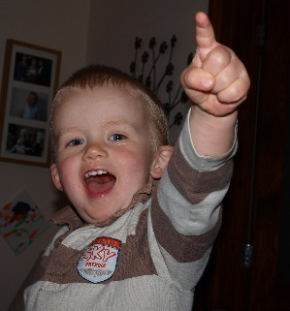

Babies and toddlers love to play with stacking cups and containers of different shapes and sizes. Play games where they stack cups to make a tower then put the cups one inside the other. They will love to play these games over and over as they learn about containers. Use the language of capacity such as **fill, full and empty.** Say **all gone** at mealtimes. Sing the rhyme I’m a little teapot. [I'm a Little Teapot - CBeebies - BBC](https://www.bbc.co.uk/cbeebies/watch/something-special-little-teapot) At bath time you could fill and empty a teapot saying the word full and empty as you pour.

Rhyme?

**Birth – 3 years**

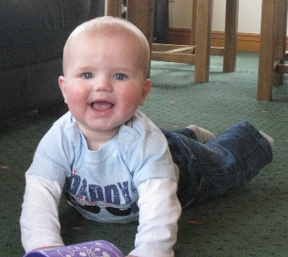

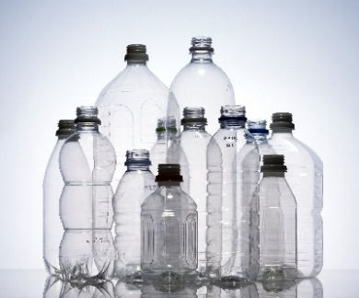

**Bath time -** Play lots of filling and emptying games. Use lots of different shaped containers and some the same so you can compare capacities while playing splashing.

**Mealtimes -** Baking, serving, eating meals are all good ways of chatting to children about capacity. Use words such as fill, full, empty.

**Shopping –** This is a good opportunity to chat about how much different packets and jars hold.

**Capacity during routines**

Children love to explore, so providing them with lots of different shapes and sizes of containers means they will naturally learn about capacity while playing. Providing a variety of materials to fill up the containers will lead to understanding of the properties of different materials. Deepen their understanding by providing the same shaped containers of different sizes. By filling and emptying they can start to learn about how much different containers hold and start to compare capacities.

**Capacity during play**

Can you find 1 box in your house that will fit inside another box?

Can you find an even bigger box that they will both fit into?

**Maths Challenge at Home –** lots more ideas in the Cumberland Early YearsMathematics Toolkit[Early Years Maths Toolkit (cumbria.gov.uk)](https://www.cumbria.gov.uk/elibrary/Content/Internet/537/1459/7037/17952/44048142650.pdf)