**Mark Making**

**Children can use marks and representations to show their mathematical ideas and thinking. This skill supports their problem solving and reasoning.**

**Making the Most of Maths**

Very young children are developing the muscles and hand to eye co-ordination they will use to make marks. Provide lots of tummy time to develop strong core muscles. Grabbing and shaking objects will develop their finger muscles. You could use edible finger paints made from food while they are still putting things in their mouths. Use big paint brushes to “paint” the walls with water, chunky chalks to make scribbles with, sticks to make lines in the mud. You could make gloop out of cornflour and water for them to draw their fingers through.

Observe as children lead their own mark making during play. Watch closely and talk about what they have represented. If you think they are ready and would enjoy it, you can also include some challenges such as “Would you like to draw 4 frogs on the log?” “Can you help me and record how I can share these strawberries between the three of us.” “I have forgotten how to get to Nana’s house- could you draw me a map?” You could provide treasure to be shared between pirates, help them to write price tags for their shop, help them find ways to keep score of a simple game by providing writing materials. Children love to use a clip board and a variety of pens and pencils to record what they are doing or can see around them.

**4 - 5 years**

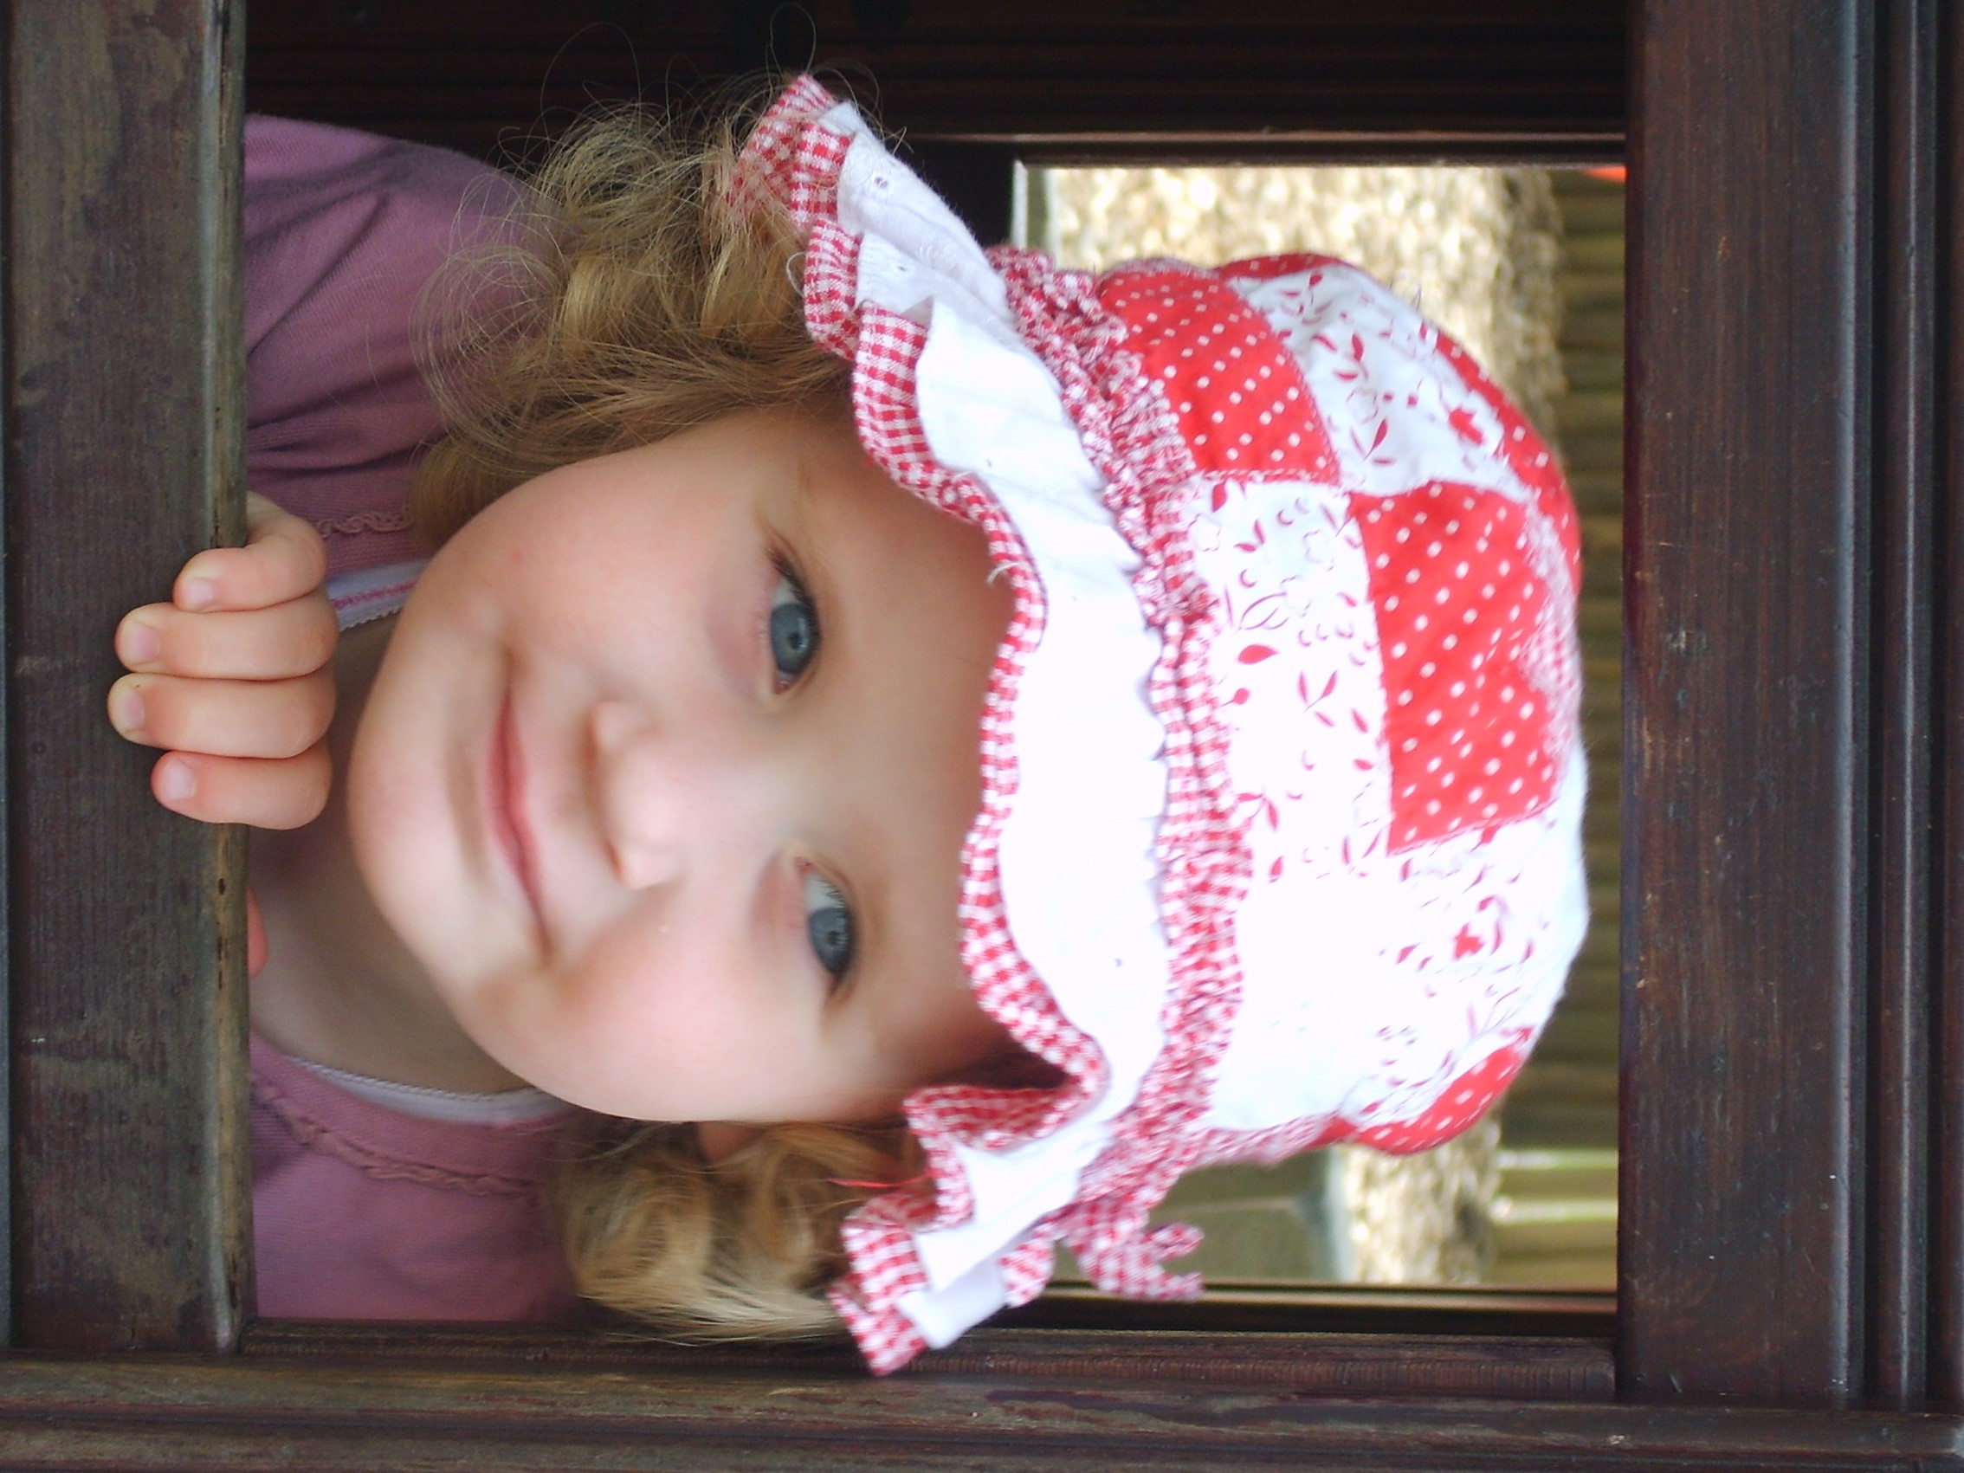

Provide lots of opportunities for children to record their mathematical thinking by having pens, paper, crayons, chalks, paints available when they are playing. They may use them to scribble, make marks, drawings, and include some symbols. Let them experiment and praise them. For example, they might make a lot of dots on a paper to show hundreds of stars or snowflakes, draw some curved lines to show they have more than one worm in their picture. They may draw a train with a number 6 to show the train they saw had a number on it. They may draw the tower they have made from bricks, representing the individual bricks.

**3 - 4 years**

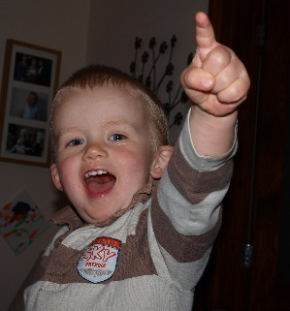

**Birth – 3 years**

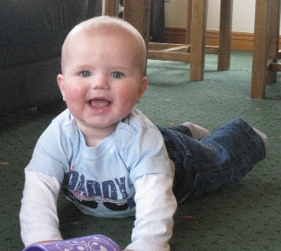

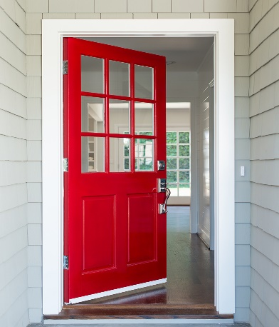

**Examples of mathematical mark making during play.**

Addition

One less than 3

How many beans make 4?

Mathematical marks that disappear

***Can you draw a plan of your house?***

***Find a way to record how many***

***doors and windows you have.***

***(To add extra challenge, draw a plan of***

***somewhere you enjoy visiting)***

**Home Maths Challenge Maths Challenge at Home –** lots more ideas in the Cumberland Early YearsMathematics Toolkit[Early Years Maths Toolkit (cumbria.gov.uk)](https://www.cumbria.gov.uk/elibrary/Content/Internet/537/1459/7037/17952/44048142650.pdf)