

**Wiggly Woo**

**There's a worm at the bottom of my garden and his name is Wiggly Woo.  
There's a worm at the bottom of my garden and all that he can do is wiggle all night and wiggle all day.  
He's wiggling his life away…  
There's a worm at the bottom of my garden and his name is Wiggly Woo.**

**Chat Play Share**

**Rhymes and songs**

**Where is Wiggly Woo?**

Games which involve following instructions will help to develop your child’s listening and attention skills. Find an old sock and stuff it with newspaper/ old packaging to make a big wiggly worm (you can add eyes if you like). Ask your child to close their eyes whilst you hide the worm inside or outside. Give them simple instructions to find the worm. For older children make it harder to find so they must listen to and follow multi-part instructions. Can they hide the worm and give you instructions to follow to find it?

**Younger Children**

Sing this song to your child and use a finger to be the worm. Each time you sing ‘wiggle’ use you wiggling finger to give them a tickle. Older toddlers might like to ‘wiggle’ along as you sing the song.

**Older Children**

Learn this song with your child and make up your own actions. Have fun together making up alliterative phrases (where each word starts with the same sound) about different minibeasts. To start with your child might need lots of help to hear the initial sound in words, but this is something good to practice. How about ‘Wiggling, wriggly worm’, ‘Big, beautiful, bright butterfly’. Can you make one up for a bee, ladybird, caterpillar? etc?

<https://www.bbc.co.uk/teach/school-radio/nursery-rhymes-wiggly-woo/zvj8gwx>

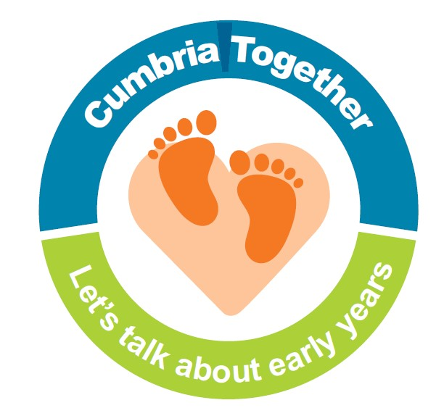

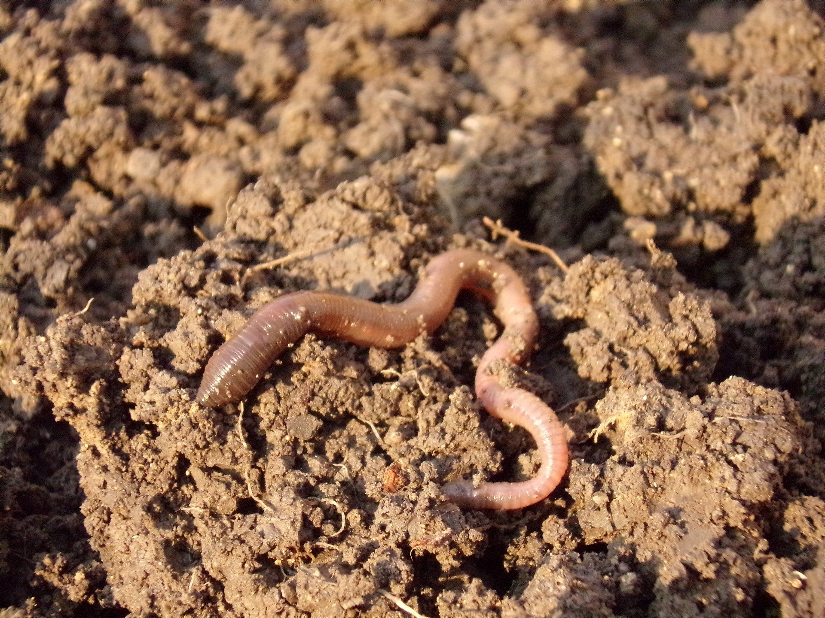

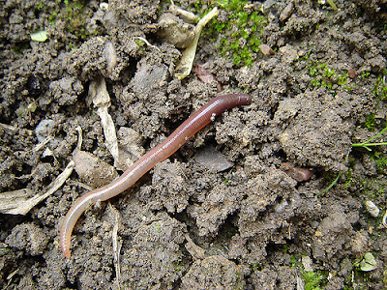

Share a story together about minibeasts and chat about the pictures and story. Examples of stories:

* Superworm by Julia Donaldson
* The very hungry caterpillar by Eric Carle
* Slug needs a hug by Jeanne Willis
* Mad about minibeasts by Giles Andreae
* Spider by Alison Steadman
* Twist and hop minibeast bop by Tony Mitton
* What the ladybird heard by Julia Donaldson

Some children prefer information books to stories and there are lots about minibeasts or child friendly information can be found on-line. How about finding out some interesting worm facts together by looking at <https://kids.nationalgeographic.com/animals/invertebrates/facts/earthworm>

**Worm hunt**

Why not go on a worm hunt together and take time to observe them closely and to chat about the length and colour of the worms you find? How many words can you think off to describe how the worms move? Worms can be found in a variety of ways including:

* Habitat hunt - Turn over stones and dead wood, look under leaf litter and dig in bare earth.
* Stamping up and down - Worms are supposed to be attracted to the surface by vibrations.
* Soaking - Thoroughly wet an area of grass, cover it with black plastic and wait for 30 minutes. The water floods the worms’ burrows and unless they come to the surface they will drown. This is why so many worms appear on the surface after rain showers.

Make sure you handle the worms with great care and put them somewhere safe to burrow again after you have looked at them! Their skin is very delicate, avoid over-handling so they don’t dry out.

(Information taken from: <https://schoolgardening.rhs.org.uk/Resources/Info-Sheet/Hunt-for-Worms>)

**Chat Play Share…Other ideas you could try….**