

We’re going to the zoo

**CHORUS:**

**We’re going to the zoo, zoo, zoo.**

**How about you, you, you.**

**You can come too, too, too.**

**We’re going to the zoo, zoo, zoo.**

(See below for verses)

**Chat Play Share**

**Rhymes and songs**

Sing each verse with the chorus repeated in between:

*1/ See all the monkeys scritch, scritch scratching. Hanging by their long tails scritch, scritch scratching. Jumping all around and scritch, scritch scratching. We can stay all day!*

*2/ See the elephants with long trunk swinging. Great big ears and long trunk swinging. Snuffing up peanuts with long trunk swinging. We can stay all day!*

*3/ See the tall giraffes with long neck stretching. Poking out tongues with long neck stretching. Munching on leaves with long neck stretching. We can stay all day!*

*4/ See the slippery seals splish, splash, splashing. Diving in the water splish, splash, splashing. Doing funny jigs and splish, splash, splashing. We can stay all day!*

*5/ Great big rhino he’s huff, huff, a-puffing. Horns too heavy he’s huff, huff, a-puffing. Don’t get too near the huff, huff, a-puffing. Or you won’t stay all day!*

**Younger children**

Sit opposite your child on the floor and sing this song to them. Don’t be tempted to sing too fast as slowing down will help your child to understand what you are saying. Emphasise the word ‘zoo’ in the chorus and see if your child starts to copy you?

<https://childrenlovetosing.com/kids-action-song/were-going-to-the-zoo/>

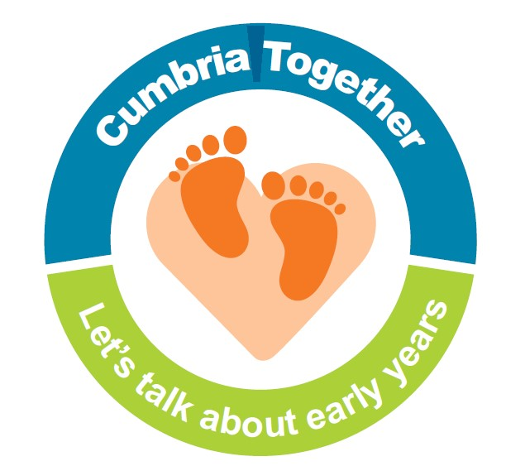

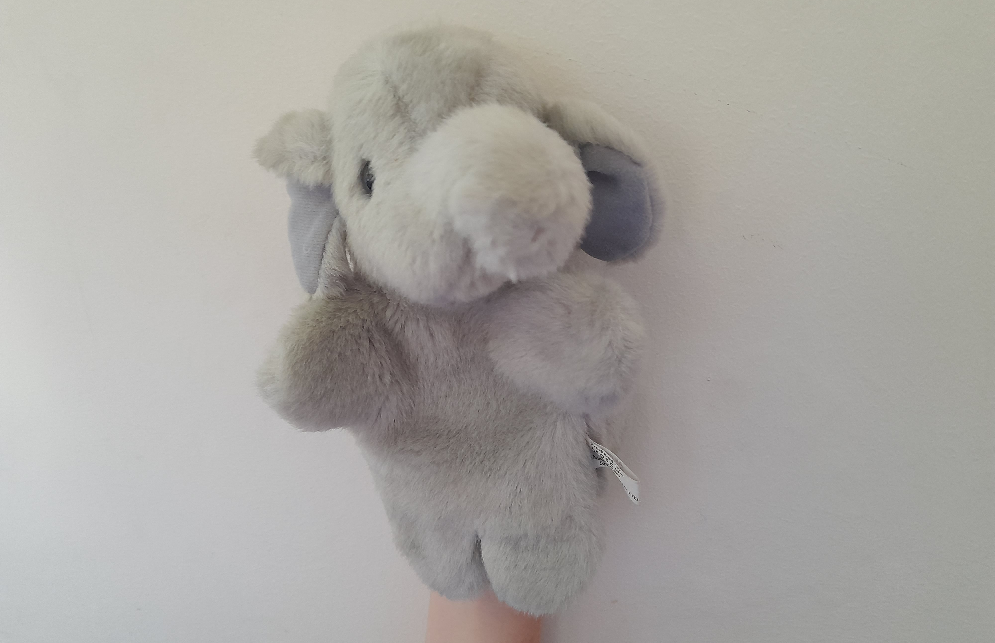

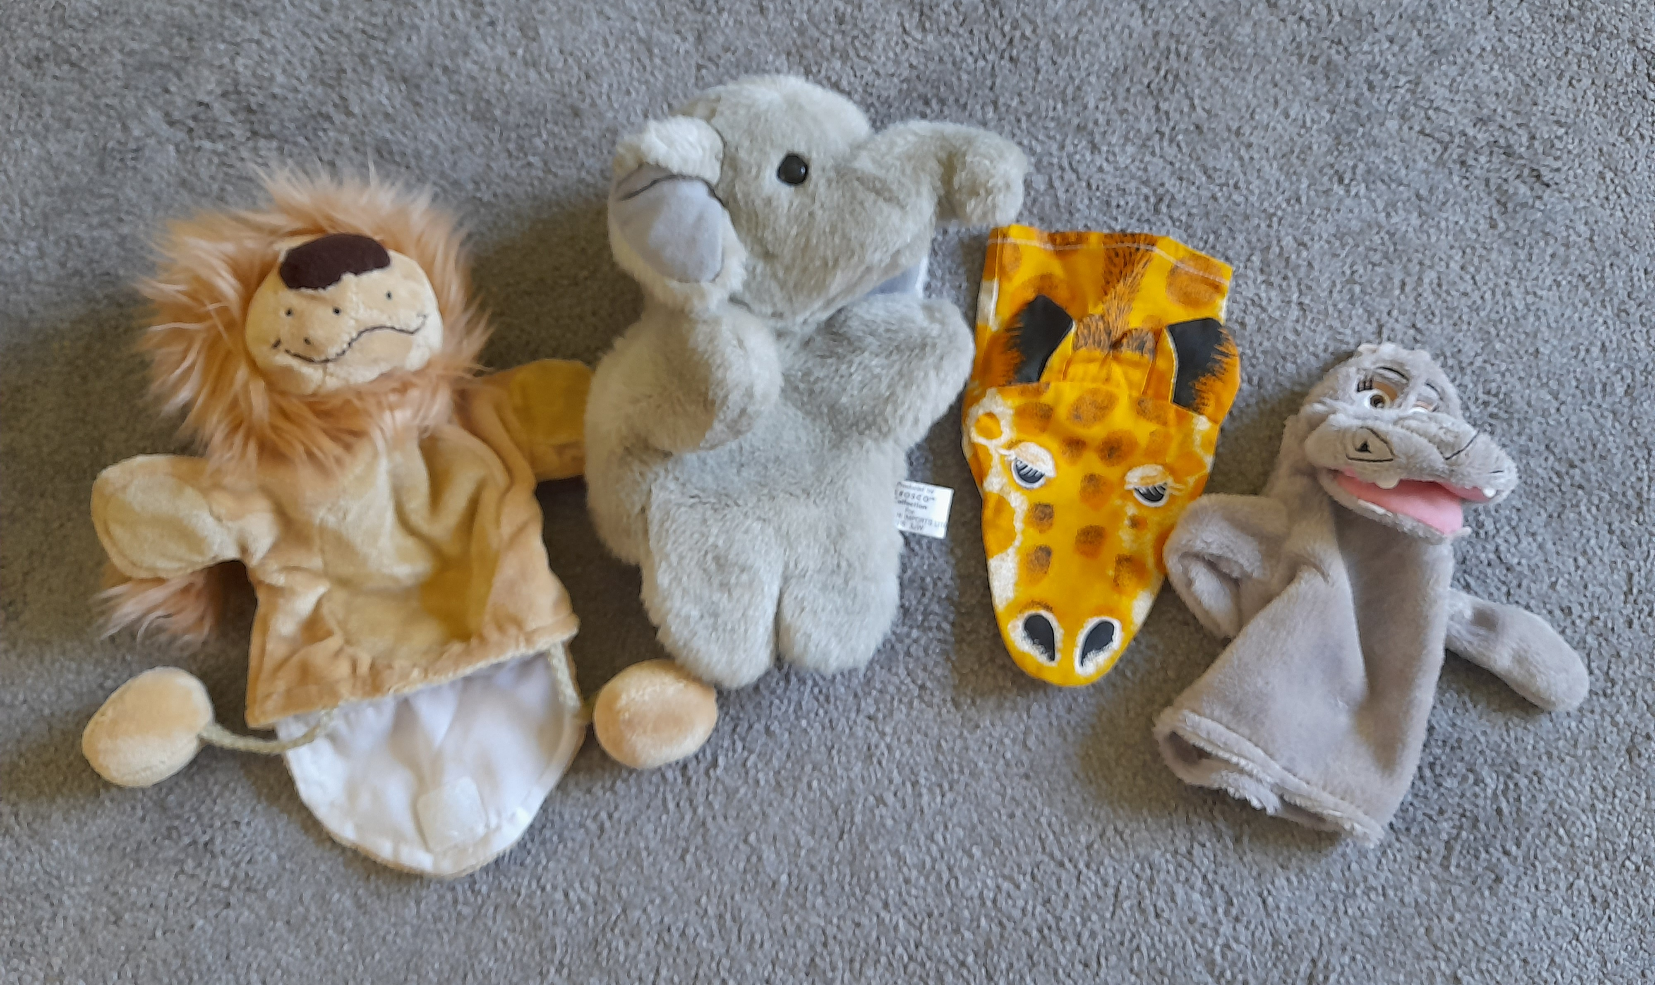

**Puppet play**

Puppet play is great for supporting children with developing their speech language and communication skills. Using puppets to act out songs can develop a child’s attention and they can then sing the songs copying what they see you do. Even shy children will often engage with a puppet! Whilst you can buy puppets, a home-made sock puppet or simple picture on a stick works well. How about finding/making some puppets to use with this song?

**Older children:**

Have fun singing the song with your child and making up actions together. It may help to learn one new verse at a time and to slow the song down to start with. If there are new words which you think your child might not know, explain simply what they mean.

**Chat Play Share…Other ideas you could try….**

Share a story together about the zoo and chat about the pictures and story. Examples of stories:

* Class two at the zoo by Julia Jarman
* One night in the zoo by Judith Kerr
* Hole in the zoo by Chloe and Mick Inkpen
* Dear zoo by Rod Campbell
* Who’s at the zoo? by Julia Donaldson
* Hullabaloo at the zoo by Zanna Davidson

**Listening game:**

It is very important for children to be able identify sounds they hear. This simple online game encourages them to listen and identify animal sounds.

<https://www.phonicsplay.co.uk/resources/phase/1/welcome-to-the-zoo>

**Rhyming strings**

‘Zoo, too, you’ rhyme and you can her this in the chorus. This means the words all have the same end/final sound. See if you can think of any other words together which rhyme with zoo? Encourage your child to listen to the final sound as you emphasise it in the word if they find it tricky. It doesn’t matter if they suggest real or made up words!