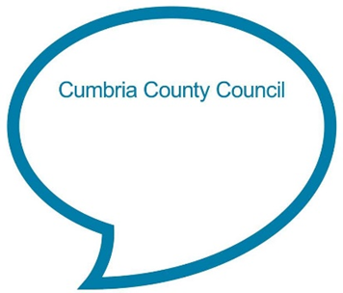

**There’s a tiny caterpillar on a leaf**

**There’s a tiny caterpillar on a leaf (wiggle, wiggle).  
There’s a tiny caterpillar on a leaf (wiggle, wiggle).  
There’s a tiny caterpillar, tiny caterpillar,  
There’s a tiny caterpillar on a leaf (wiggle, wiggle).**

(Sing to the tune ‘She’ll be coming round the mountain’. See below for additional verses)

**Chat Play Share**

**Rhymes and songs**

**Additional verses:**

*He will eat the leaves around him ‘til he’s full (munch, munch). He will eat the leaves around him ‘til he’s full (munch, munch). He will eat the leaves around, eat the leaves around. He will eat the leaves around him ‘til he’s full (munch, munch)*

*A cocoon is what he’s spinning for his home (spin, spin). A cocoon is what he’s spinning for his home (spin, spin). A cocoon is what he’s spinning, cocoon is what he’s spinning. A cocoon is what he’s spinning for his home (spin, spin).*

*Then he’ll be a butterfly and flap away (flap, flap). Then he’ll be a butterfly and fly away (flap, flap). Then he’ll be a butterfly, be a butterfly. Then he’ll be a butterfly and fly away (flap, flap).*

**Younger children:**

Sing the song slowly and softly to your child and use your fingers to add in actions for them to watch. See if your child follows your hand with their eyes as you do the actions. Children who are walking may like to copy actions you add in, such as wriggling on the floor (caterpillar on a leaf) or flapping arms (butterfly flying away) and with repetition will hopefully start to join in with odd words or phrases.

<https://www.snapdragonsnursery.com/nursery-rhymes/2017/9/25/theres-a-tiny-caterpillar-on-a-leaf>

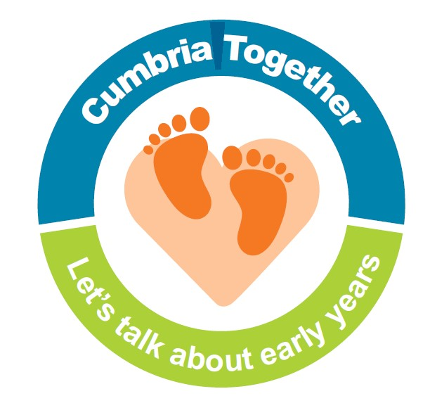

**Chat Play Share…Other ideas you could try….**

Share a story together about a caterpillar/butterfly and chat about the pictures and story. Examples of stories:

* The very hungry caterpillar by Eric Carle
* Ten little caterpillars by Bill Martin Jr
* The crunching munching caterpillar by Sheridan Cain
* Butterfly butterfly by Petr Horacek
* The butterfly dance by Suzanne Barton

‘The very hungry caterpillar’ is one of the most read children’s books ever. On the authors website ([www.eric-carle.com](http://www.eric-carle.com)) there are lots of activities linked to this and his other books, including a summer activity challenge. Why not try to complete the activities together. New experiences are great opportunities to learn new words and as focus for chatting together: <https://eric-carle.com/wp-content/uploads/2019/11/activity_month_july19.pdf>

**Listening Game**

Agree a set of actions for different parts of the caterpillar’s life cycle e.g. wriggling caterpillar, flying butterfly, cocoon spinning, little egg and munching caterpillar. Put on some music (like for musical bumps or statues). When you stop the music call out one of the actions and see how quickly your child can listen and respond to the instruction.

Some children prefer information books to stories and there are lots about the life cycle of a caterpillar or child friendly information can be found on-line. How about finding some caterpillar facts together, looking at pictures of different caterpillars and talking about their differences or helping older children to learn about their lifecycle by using the children’s National Geographic website: <https://www.natgeokids.com/uk/discover/animals/insects/butterfly-life-cycle/>

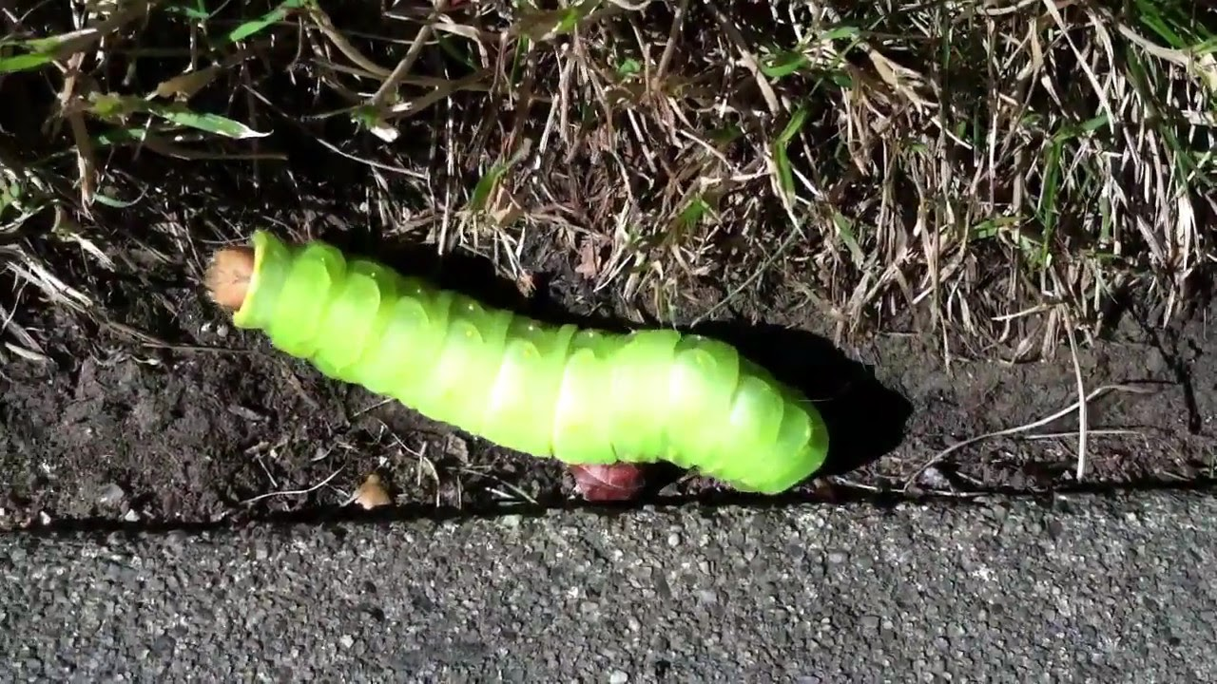

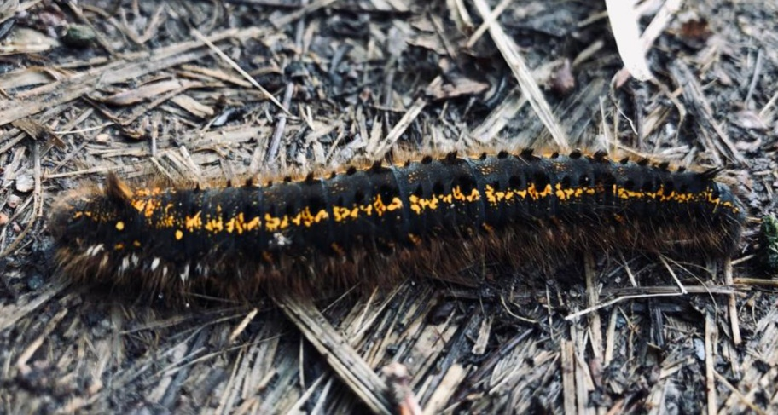

**Older children:**

Enjoy learning the song together and adding in actions. Practice clapping or tapping out the syllables in caterpillar (cat-er-pill-ar) and butterfly (but-ter-fly) then build up rhythmic patterns by clapping/tapping out the words in strings e.g. caterpillar, caterpillar, butterfly, butterfly, caterpillar, caterpillar. You could also add in other connected words.