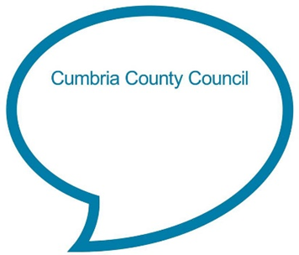

**Ten fat sausages**

**Ten fat sausages sizzling in a pan, one went pop, and another went bang!**

**Eight fat sausages sizzling in a pan, one went pop, and another went bang!**

**Six fat sausages….**

**Four fat sausages…**

**Two fat sausages…**

**Chat Play Share**

**Rhymes and songs**

**Alternative song version**

This version may be more appropriate for use with young children as they only need to take away one sausage at a time.

Five fat sausages frying in a pan, all of a sudden - one went "BANG"!  
Four fat sausages frying in a pan, all of a sudden - one went "BANG"!  
Three fat sausages frying in a pan, all of a sudden - one went "BANG"!  
Two fat sausages frying in a pan, all of a sudden - one went "BANG"!  
One fat sausages frying in a pan, all of a sudden - one went "BANG"!  
No fat sausages frying in a pan.

**Younger Children**

This is a great song to use at mealtimes, particularly if you are having sausages. Say the rhyme quietly to your child as you sit with them. Emphasise the ‘pop’ and ‘bang’ sounds and see if they start to try and copy you.

**Older Children**

Learn the rhyme with your child. Say it slowly together to get started. See if your child can add in ‘pop’ and ‘bang’ in the right places if you pause. Encourage your child to use their fingers to show how many sausages are left as you do the same. Give them chance between each verse to count how many sausages are left and provide help if needed.

<https://www.bbc.co.uk/teach/school-radio/nursery-rhymes-ten-fat-sausages/z6vh7nb>

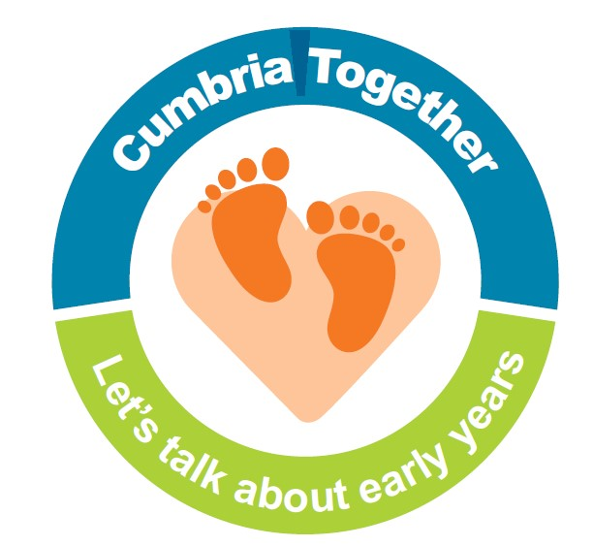

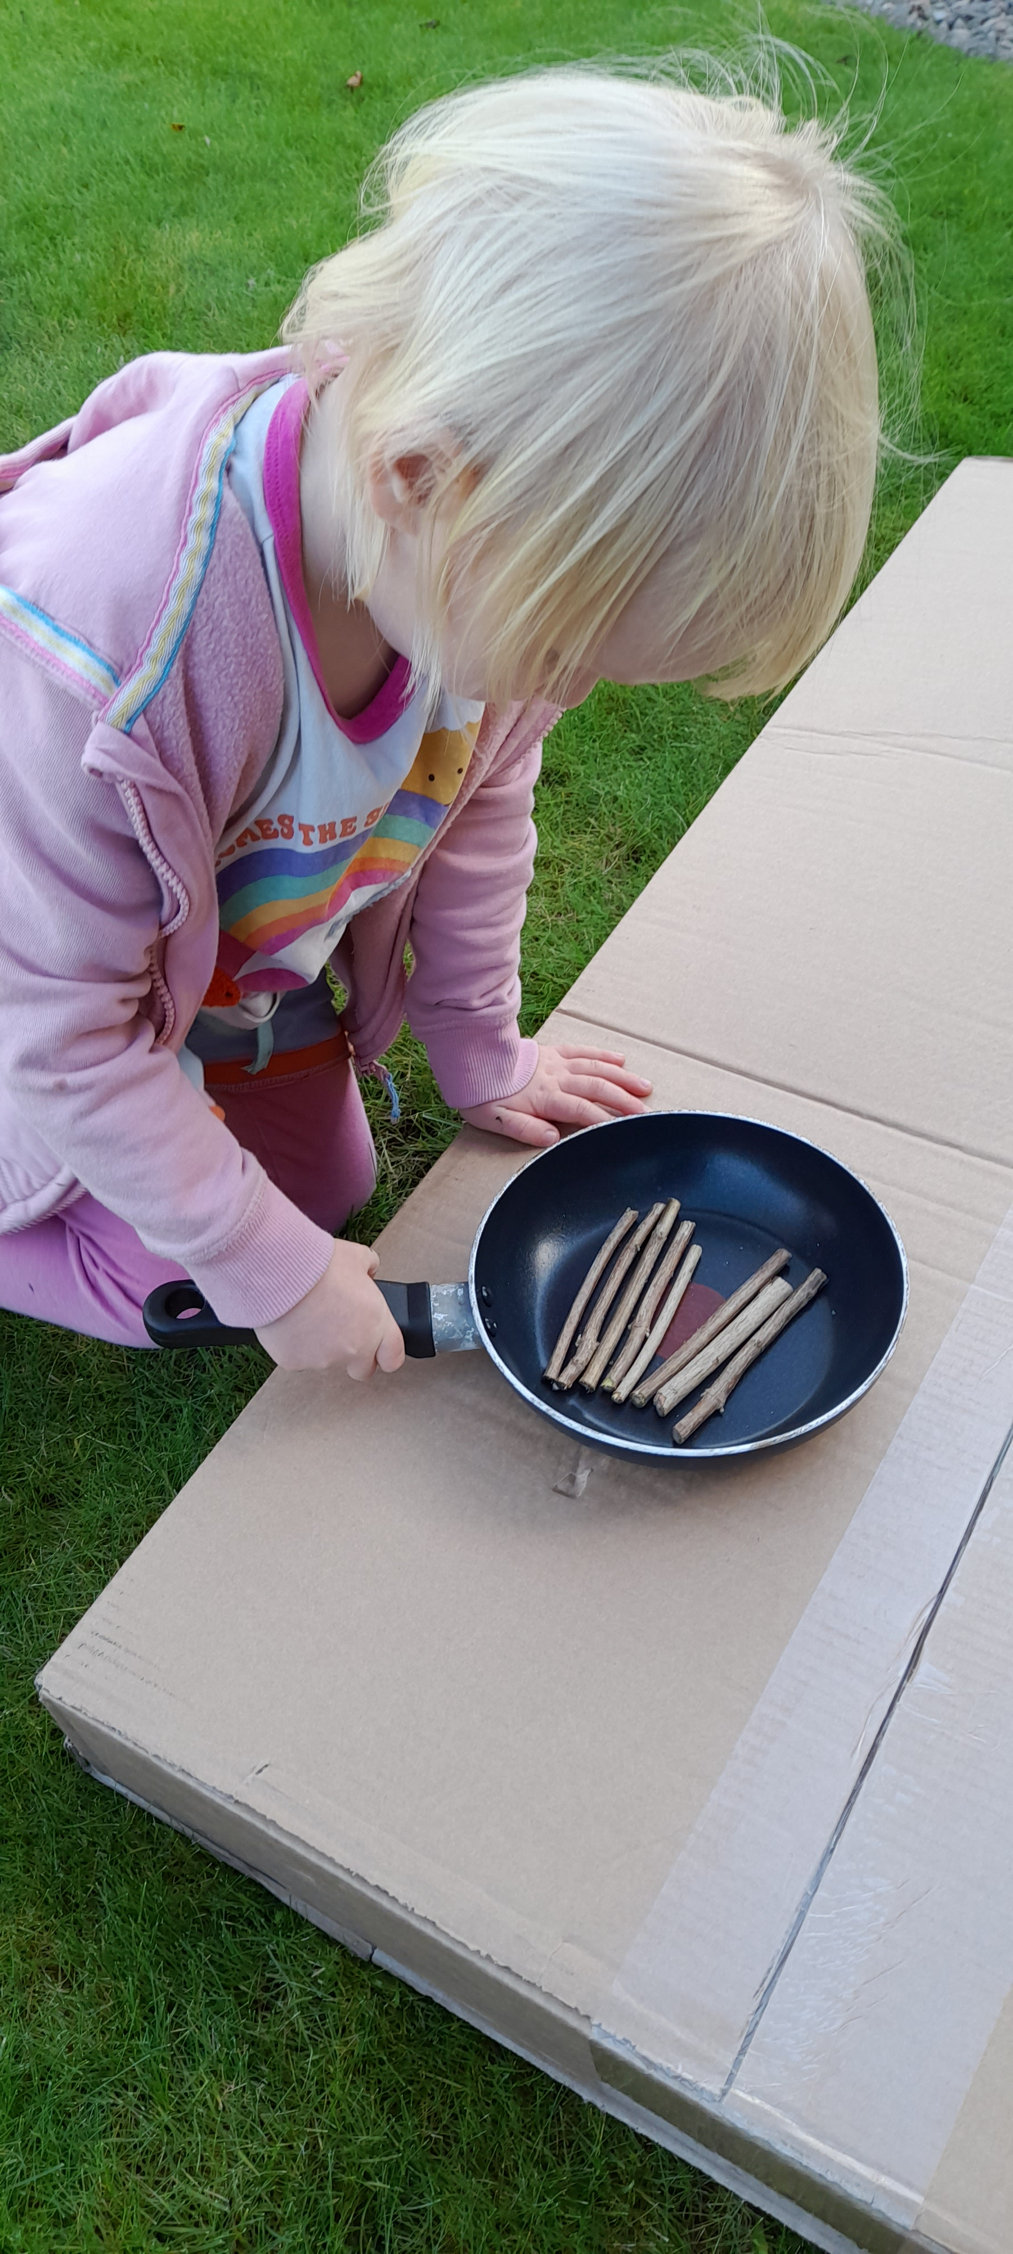

Share a story together with a food theme and chat about the pictures and story or look at an information book together. Examples of stories:

* Feast for 10 by Cathryn Falwell
* Pop Pop and me and a recipe by Irene Smalls
* Eating the alphabet by Lois Ehlert
* I will never not ever eat a tomato by Lauren Childs
* Ketchup on your cornflakes by Nick Sharratt
* Kitchen disco by Clare Foges and Al Murray
* Oliver’s Vegetables by Vivian French
* Baby goes to market by Atinuke

**Song role play**

**Playing with Onomatopoeia**

Onomatopoeia is a word that sounds like what it means. They help you hear what is going on. **'Thud'**, **'crash'** and **'buzz'** are all examples, as are **‘pop’** and **‘bang’** in this song. Whilst your child won’t understand what the word means it can be fun making and exploring different voice sounds together or you could model them in play. Animal and vehicle sounds are often onomatopoeic e.g. **'roar'**, **'meow'**, **'moo'**, **'brum'**, **'honk '**. Look round your home or garden together to see which objects or actions you could link to a sound; have fun making things up together and praise your child if they come up with suggestions. Can you find items which might go: **ping**, **wham**, **boing**, **squelch**, **whizz**, **shhhh, chink, bop?**

**10 fat sausages interactive game**

An interactive version of the song you could play together whilst hearing the sounds can be found at: <https://www.ictgames.com/mobilePage/fatSausages/>

This is a great song to act out inside or outdoors. Find a frying pan and something to use as sausages or cut sausage shapes out of paper. Count the sausages with your child as they put them all in the pan, then encourage them to take the right amount away at the end of each verse as you say the rhyme together. This is a good chance to introduce mathematical vocabulary such as less, take away and subtract as well as learning number names.

**Chat Play Share…Other ideas you could try….**