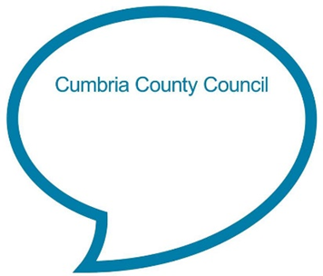

**Sleeping Bunnies**

**See the little bunnies sleeping til it’s nearly noon. Shall we wake them with a merry tune?**

**They're so still, are they ill?**

**No! Wake up bunnies!**

**Hop little bunnies, hop, hop, hop. Hop little bunnies, hop, hop, hop. Hop little bunnies, hop, hop, hop. Hop little bunnies, hop and stop!**

**Chat Play Share**

**Rhymes and songs**

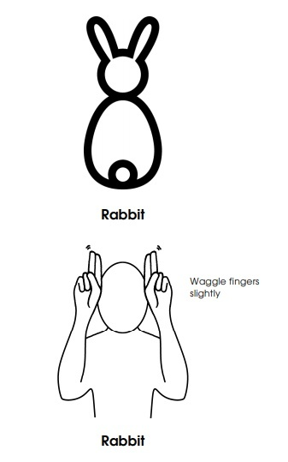

Many children learn some sign language or Makaton at school/nursery. Simply explain that some people use signs with or instead of words. Learn to sign ‘rabbit’ together. If your child is interested in learning more animals, you could search for: *‘Makaton topic -Farm Animals – Singing Hands’* on YouTube.

**Younger Children**

Sit your child facing you on your knee. Sing the first part slowly and very quietly, then sing the second part with more volume and speed. Bounce your child up and down each time you say ‘hop’.

If you have a soft toy rabbit you could sing the song and act it out using the rabbit. See if your child follows the rabbit with their eyes as you jump it around.

**Older Children**

Sing the song through with your child once first, then suggest they lie down on the floor like a sleeping bunny. When you get to ‘hop little bunnies’ encourage them to jump up and hop/jump around. With practice see if they can listen carefully and jump up as soon as you say ‘hop’ (even if you vary the gap between the two parts of the song) and stop jumping quickly when you say ‘stop’. This is a good way of practising listening skills.

<https://wordsforlife.org.uk/activities/sing-sleeping-bunnies-your-child/>

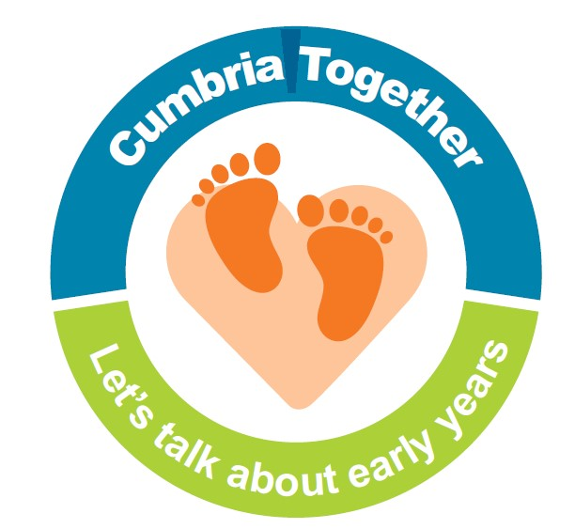

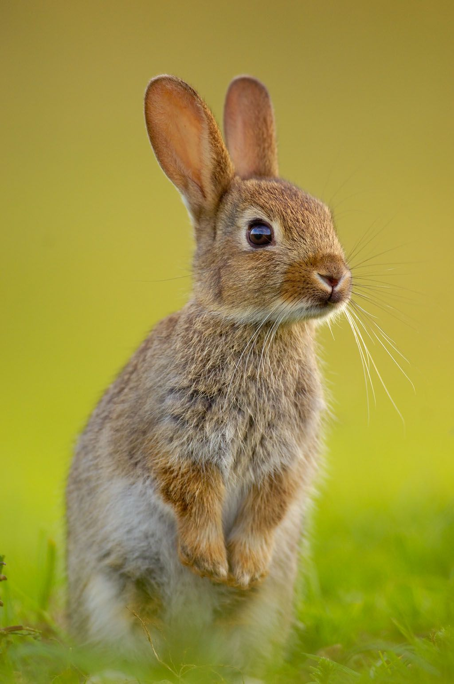

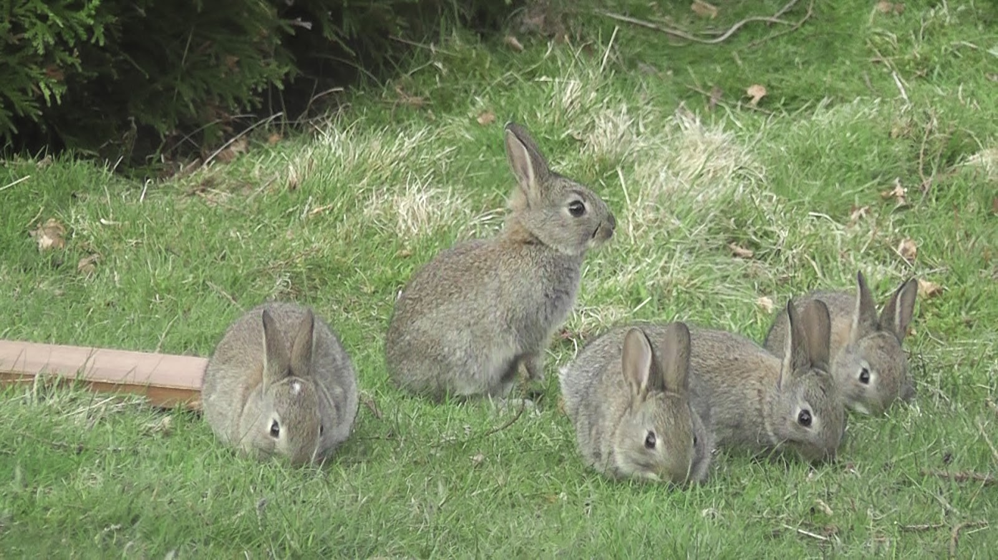

**Family Tree**

Rabbits often live in very big family groups. Talk with your child about who is in your family. Who can they name and talk about? How about drawing a simple family tree together or sharing some old photographs? Talk about all families being different, but all being special. Some are big, some small, some all live close together and others far apart.

**Listening Ears**

Rabbits have very good hearing. Make a simple set of rabbit ears attached to a cardboard headband for your child (and for you?!) to wear. Go outside together and encourage your child to listen carefully. Tell your child what you can hear and give them time to share what they can hear.

Share a story together about rabbits/hares and chat about the pictures and story. Examples of stories:

* Hop little bunnies by Marth Mumford
* That’s not my bunny by Fiona Watt
* Guess how much I love you by Sam McBratney
* The rhyming rabbit by Julia Donaldson
* Peter rabbit by Beatrix Potter
* Five little easter bunnies by Martha Mumford

**Talk together about…**

* How ‘rabbit’ or ‘bunny’ can both be used but that they are the same animal.
* The features a rabbit has (big feet, tail, ears, whiskers) by looking at a photo or drawing one together.
* Other animals which hop/jump. How many can you think of? Which does your child think will be able to jump the furthest?
* Older children might like to learn some rabbit facts:

<https://www.natgeokids.com/uk/discover/animals/general-animals/10-hopping-fun-rabbit-facts/>

* How rabbits live in a warren with lots of other rabbits and how they are very good at digging burrows to get to their warren. Look out for rabbit burrows next time you are out in the countryside.

**Chat Play Share…Other ideas you could try….**