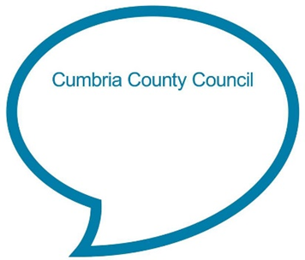

**One finger, one thumb, keep moving**

**One finger, one thumb, keep moving.  
One finger, one thumb, keep moving.  
One finger, one thumb, keep moving.**

**We’ll all be merry and bright.**

(Further verses below)

**Chat Play Share**

**Rhymes and songs**

**Additional verses**

*One finger, one thumb, one arm, keep moving. One finger, one thumb, one arm, keep moving. One finger, one thumb, one arm, keep moving. We’ll all be merry and bright.*

*One finger, one thumb, one arm, one leg, keep moving. One finger, one thumb, one arm, one leg, keep moving. One finger, one thumb, one arm, one leg, keep moving. We’ll all be merry and bright.*

*One finger, one thumb, one arm, one leg, one nod of the head, keep moving. One finger, one thumb, one arm, one leg, one nod of the head, keep moving. One finger, one thumb, one arm, one leg, one nod of the head, keep moving. We’ll all be merry and bright.*

*We’ll all be merry and bright.*

**Younger Children**

For a baby, lie them on the floor as you sing the song to them slowly and gently. Point to your finger, your thumb and nod your head following the instructions in the song and see if they watch you. When you sing ‘one arm’ and ‘one leg’ tickle their arm/leg.

For a toddler, encourage them to copy you and point to or move their different body parts as you sing the song nice and slowly.

<https://www.bbc.co.uk/teach/school-radio/nursery-rhymes-one-finger-one-thumb-keep-moving/zbtj47h>

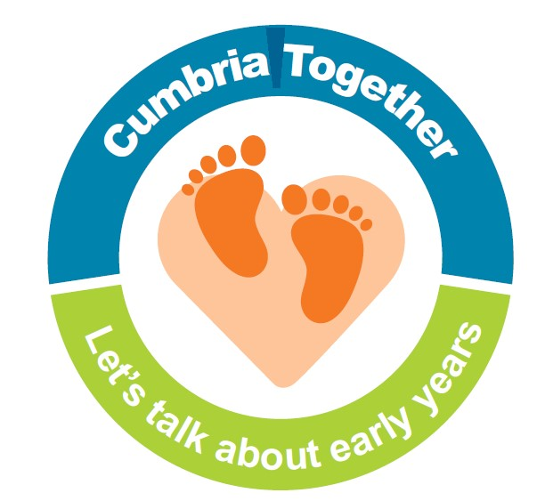

Children are often very interested in finding out about their body and how it works. Why not look out for a simple information book in your local library you can share and chat about together?

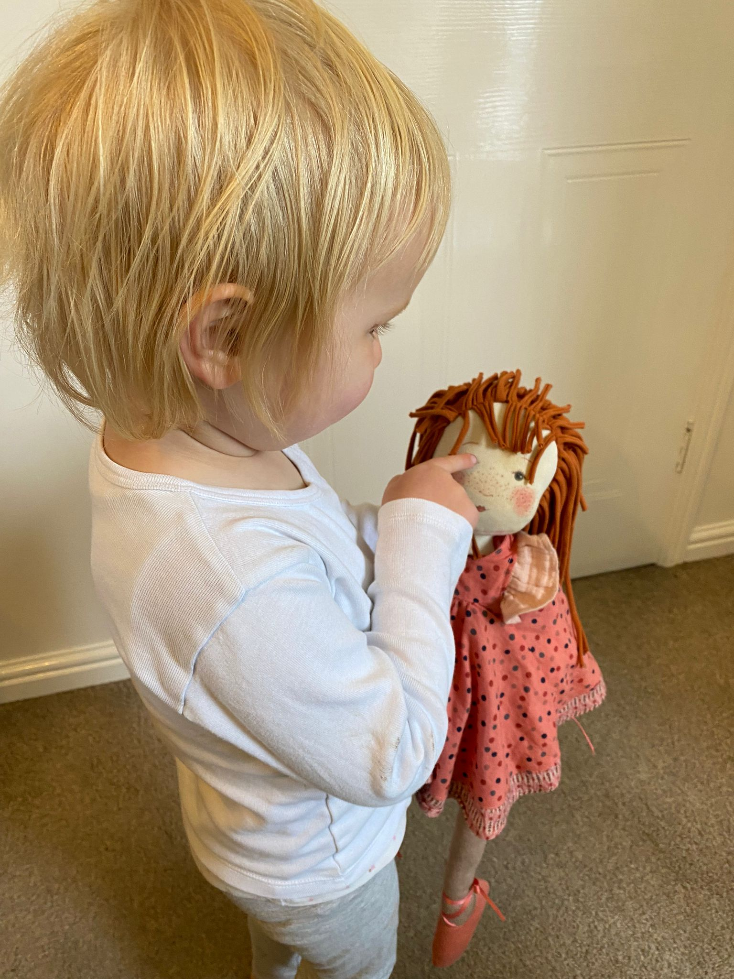

Simon says…

Teach your child to play ‘Simon says’ (Encourage your child to listen carefully. If you say ‘Simon says pat your head’ for example, they do it, but if you just say ‘pat your head, they don’t). Use instructions connected to different body parts such as ‘stamp your feet, clap your hands, pat your knees, blink your eyes’. Younger children may need longer to process the instruction and to start the action so give them time. Praise your child for good listening if they get it right and increase the volume of ‘Simon says’ if they are finding it tricky to hear the difference. Older children who understand the game well may like a go at being Simon.

Finding body parts

This song names several different body parts. See if your child can listen and point to different parts of their body as you name them (younger children may find it easier to find them on a teddy/doll). For younger children start with main body parts such as eyes, tummy, hand. If they point to the right place reiterate the part found so they hear the word again, for example ‘Yes, your eyes’. Introduce other body parts as your child gets older or slightly change the instruction and see if they notice, for example, ‘Where’s daddy’s ears?’.

**Older children**

Encourage your child to join in the actions and wiggle each body part as it is mentioned in the song. Start off slowly singing the first verse and gradually get quicker and see if your child can keep up with listening and adding the correct actions.

When singing the last verse, once your child knows the song, add in a different instruction instead of ‘one nod of the head’ and see if your child notices as this means they are listening carefully. For example, ‘*One finger, one thumb, one arm, one leg, jump up, keep moving’.* Encourage them to listen carefully and add in the new actions as you sing.

**Chat Play Share…Other ideas you could try….**