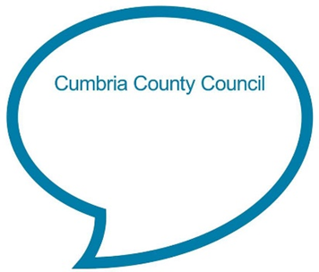

**The Hokey Cokey**

**You put one hand in, one hand out.  
In, out, in out, shake it all about.  
You do the Hokey Cokey, and you turn around.  
That’s what it’s all about.**

**Whoa-o the Hokey Cokey,  
Whoa-o the Hokey Cokey,  
Whoa-o the Hokey Cokey.  
Knees bend, arms stretch rah, rah, rah!**

**Chat Play Share**

**Rhymes and songs**

<https://www.bbc.co.uk/teach/school-radio/nursery-rhymes-the-hokey-cokey/zrcnmfr>

**Additional verses:**

*You put one foot in, one foot out. In, out, in out, shake it all about. You do the Hokey Cokey, and you turn around. That’s what it’s all about.*

*Whoa-o the Hokey Cokey, Whoa-o the Hokey Cokey, Whoa-o the Hokey Cokey. Knees bend, arms stretch rah, rah, rah!*

*You put your whole self in, your whole self out. In, out, in out, you shake it all about. You do the Hokey Cokey, and you turn around. That’s what it’s all about.*

*Whoa-o the Hokey Cokey, Whoa-o the Hokey Cokey, Whoa-o the Hokey Cokey. Knees bend, arms stretch rah, rah, rah!*

**Younger children**

Sit facing your child as you sing the sing and model the actions. Start off singing very quietly and get louder as you get to the chorus. If your child has started to toddle, hold their hands and encourage them to join in.

**Older children**

Have fun singing this song together and adding in the actions. Start off singing slowly so your child has time to learn the actions, then gradually increase the speed.

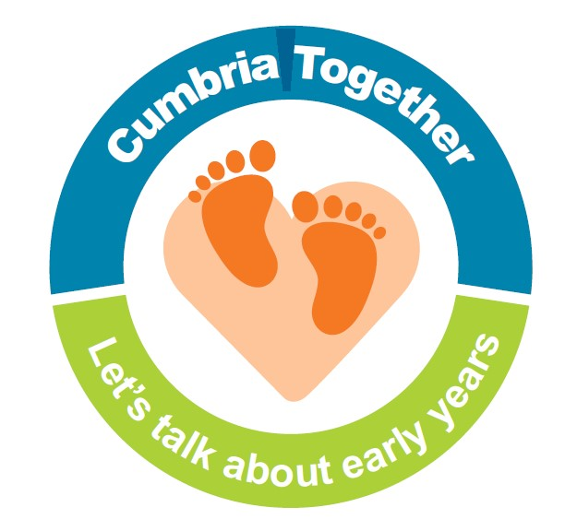

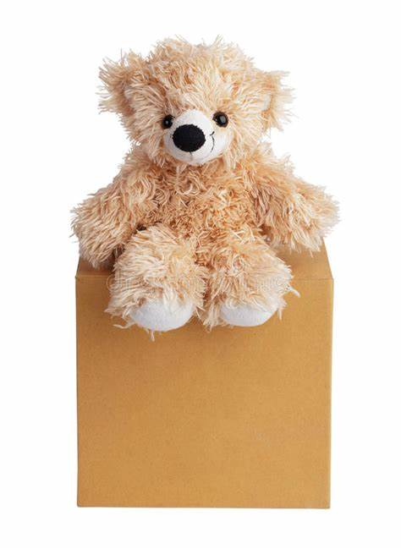

Traditionally ‘The Hokey Cokey’ was often sung at children’s parties. Chat with your child about party games you remember playing as a child. See if your child can remember any party games they have played. Why not play musical statues together? Encourage your child to listen carefully to the music and stop as still as a statue, as quickly as they can when the music stops. See if your child can still stop quickly even when you turn the music volume down low, so they have to listen really carefully.

Young children often really enjoy songs like the Hokey Cokey which involve actions or dancing. Why not look out for a song or rhyme book in your local library, charity shop or bookshop and have fun singing and dancing together? Examples of suitable books:

* Play songs by Sheena Roberts
* Action rhymes by Axel Scheffler
* Finger rhymes by John Foster
* Wiggle my toes by Kaye Umansky
* Action rhymes by Felicity Brooks
* Wriggle and roar by Julia Donaldson
* Tickle my nose by Kaye Umansky
* Oranges and lemons by Karen King
* This little puffin by Elizabeth Matterson

**Left and right**

If your child is at the stage where they are learning the difference between left and right, this song can be adapted to support this. Instead of singing ‘put one hand in’, sing ‘put your left hand in’ then sing another verse for ‘put your right hand in’. Before repeating with each leg. To start with you might need help to choose the right leg or arm each time! If your child already knows left from right, muddle up the verses in the song and sing in a different order to see if your child can listen carefully and add the right action.

**Positional language**

Children need to understand the meaning of ‘in’ and ‘out’ in order to sing this song. Find a soft toy and a box and let your child practise putting the toy in and out of the box. Why not teach your child other positional language such as ‘in front’, ‘behind’, ‘next to’ ‘on’ or ‘under’. When you’re out and about ask your child simple questions about where objects are in relation to other objects so they can use the words they’ve learnt.

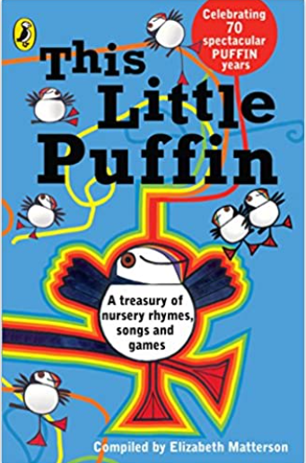

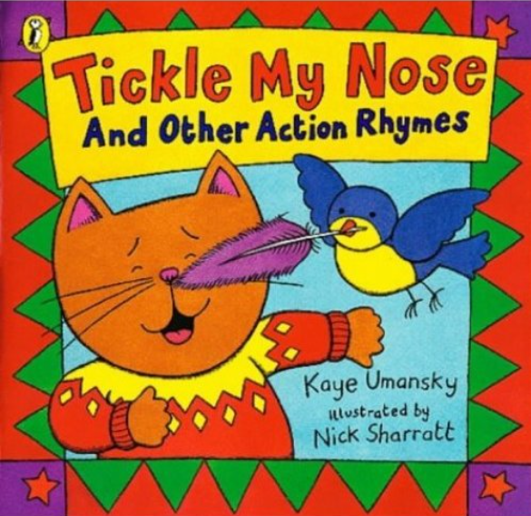 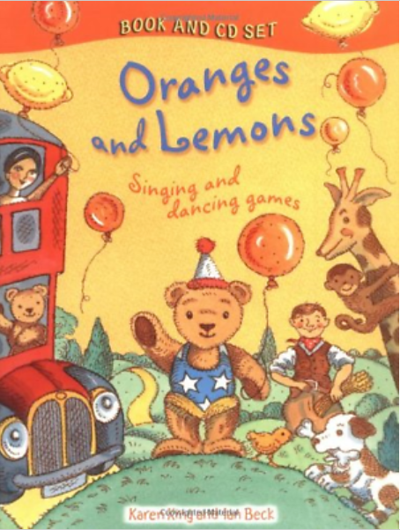

**Chat Play Share…Other ideas you could try….**