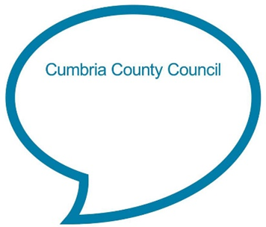

**Down in the jungle**

**Down in the jungle where nobody goes,**

**there's a little baby elephant washing his clothes.**

**With a rub-a-dub here,**

**and a rub-a-dub there.**

**That's the way he washes his clothes.**

**Chat Play Share**

**Rhymes and songs**

**Additional verses:**

*Down in the jungle where nobody goes, there’s a little baby lion washing her clothes. With a rub-a-dub here, and a rub-a-dub there. That's the way she washes her clothes.*

*Down in the jungle where nobody goes, there's a little baby monkey washing his clothes. With a rub-a-dub here, and a rub-a-dub there. That's the way he washes his clothes.*

**Younger Children**

This jolly song is great to sing at bath time. Try to emphasise the rhythm as you sing it to your child. Encourage them to pretend to wash the clothes in the bath each time you sing ‘rub-a-dub’ (or give them a flannel to wash).

**Older Children**

Talk with your child about this being a funny song as obviously animals don’t have clothes to wash! Have fun learning to sing the song together and try to get into a funky jungle beat. You could pretend to play the drums as you sing!

See if you can start off singing each verse quietly and then get louder as you get to the end. It’s good for children to be able to recognise and make quiet and loud sounds.

<https://www.bbc.co.uk/teach/school-radio/nursery-rhymes-down-in-the-jungle/zfqgscw>

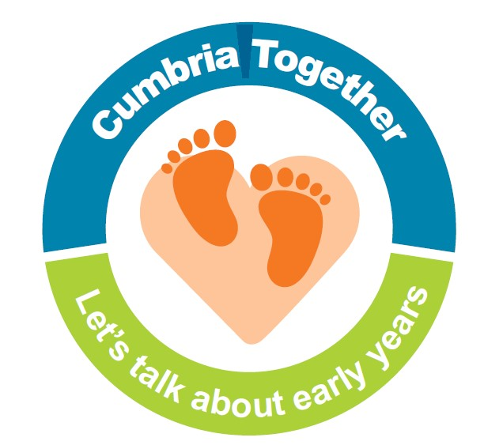

**Let’s dance**

As well as being good for wellbeing, listening to music and dancing to the beat is a great way to develop listening skills and a sense of rhythm. Why not put on your favourite music and have a dance together?

**Syllable clap**

Think about the different animals you have been singing about. Show your child how to clap once as you say each part/ or syllable of an animal name e.g. lion - **/li/** (clap) **/on/** (clap). When clapping out syllables, hold your hands wide apart when you are saying the syllables. Making a “big clap” helps children to hear and see the number of syllables. Try to have your child clap and say the syllable at the same time. Start off with one or two syllable animal names, then when they get the idea, try animals such as ‘kang/a/roo or el/e/phant’. See if you can start to clap out different rhythms by clapping out several animals one after another. Being able to hear and identify syllables will help when your child starts to learn to read and spell.



**Mix it up!**

Collect some animal soft toys (or pictures) in a bag/box or pillowcase. Once your child knows the song well get them to put their hand into the bag and pull out a soft toy. Sing a verse of the song with them about that animal, for example, ‘there’s a little baby sloth washing her clothes’. Can your child sing the verse without your help? Older children could try to think of other ways to change the song by substituting words in place of ‘little baby….’e.g. ‘enormous crocodile’ or ‘roaring tiger’.

Share a story together about jungle animals and chat about the pictures and story or look at an information book together. Examples of stories:

* Giraffes can’t dance by Giles Andreae
* Monkey puzzle by Julia Donaldson
* Jazzy in the jungle by Lucy Cousins
* Rumble in the jungle by Giles Andreae
* Party animals by Tony Mitton
* In the jungle by Axel Scheffler
* Tanka tanka skunk by Steve Webb

**Chat Play Share…Other ideas you could try….**