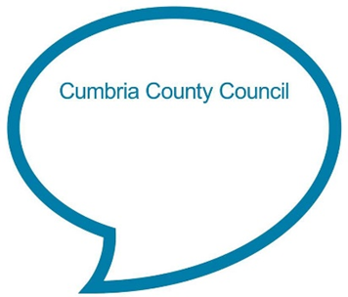

**Doctor Foster went to Gloucester**

**Doctor Foster went to Gloucester,  
In a shower of rain.  
He stepped in a puddle,  
Right up to his middle,  
And never went there again!**

**Chat Play Share**

**Rhymes and songs**

Some rhymes we sing with children are very old and are based on actual events. The ‘Doctor Foster’ rhyme dates back to the early 19th century when**King Edward I (Doctor Foster) fell from his horse into a large oozy puddle while he visited Gloucester!**

**Another popular rhyme about the rain from the 17th century is:**

Rain, rain go away. Come again another day. Rain, rain go away. Little Johnny wants to play.

**Younger children**

Hold your child in your arms and rock them gently in time with the rhythm as you softly chant the ‘Rain, rain go away’ chat, whilst watching the rain out of the window. Use your child’s name in place of ‘Johnny’.

**Older children**

Why not teach your child these rhymes on a wet day as your look out at the rain? See if you can find a big raindrop on the window and watch it together as it runs all the way down as you chant ‘Rain, rain, go away’. Talk about rhymes often being a bit funny or good at exaggerating the facts – it would have to have been a very big puddle to come up to Doctor Foster’s middle! Encourage your child to make up actions to go with the words as you sing the song.



<https://www.bbc.co.uk/teach/school-radio/nursery-rhymes-doctor-foster-went-to-gloucester/zhkf6v4>

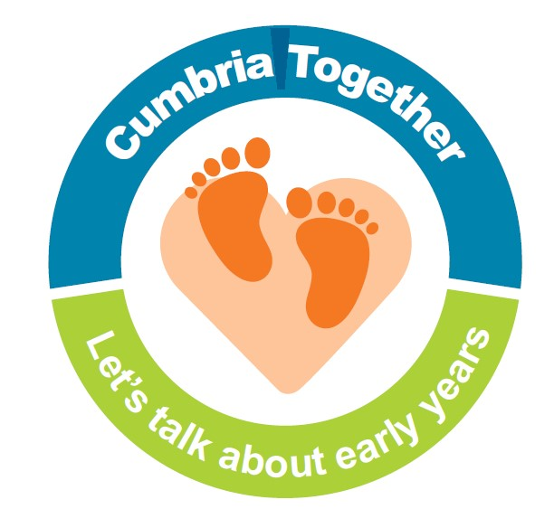

**Weather watch**

Young children are often really interested in the weather. Regularly chat with your child about the weather and teach them new words to describe it. Think about using different senses to describe what the weather feels, sounds, smells or looks like. Can your child talk about their favourite kind of weather and why they like it? Help them to learn to talk in the past tense by talking about what the weather was like yesterday or at the weekend.

Next time it rains, why not look for puddles together? Talk to your child about suitable clothing/ footwear for splashing in puddles and see if they can follow simple instructions to get themselves ready (or at least help). When you find a puddle, stop and look at it first. Does your child think it will be deep enough to come up to their middle like in the rhyme? Think of words you can use to describe the sounds as you splash in the water (e.g. Splish, splosh, whoosh, slosh, plop). See if your child can start and stop splashing promptly by listening out for you saying ‘go’ and ‘stop’. (Remember to wash hands afterwards if your child has come into contact with the water).



Share a weather themed story or information book together and chat about the pictures and story. Examples of books:

* Stormy weather by Debi Gliori
* Kippers book of weather by Mick Inkpen
* Maisy’s wonderful weather book by Lucy Cousins
* Rain, rain go away! by Caroline Church
* Elmer’s weather by David McKee
* All about weather by Huda Harajli
* Weather and the seasons – projects to make and do by DK

Why not look and see if you can find any books about the weather in your local library?

There are lots of fun ideas for weather-based activities on the BBC Tiny happy people website. Why not have a look together:

<https://www.bbc.co.uk/tiny-happy-people/fun-weather-activities/z47xqfr>

**Chat Play Share…Other ideas you could try….**